The Case for Coal:
· Just like an investment portfolio, diversification in an energy portfolio is key to stable energy pricing
· The Lower 48 uses a mix of coal (35-50%), gas (20-30%), Nuclear (20%) and a mix of other minor sources to provide it energy to Americans
· Alaska, on the other hand, relies on over 70% of its electrical generation fuel on gas and oil, with hydro kicking in just over 20%
· Recent construction – to exacerbate our reliance, we have added an additional 450 MW (or are in the process of adding) in the Railbelt over the past decade. This includes GVEA’s North Pole plant (naphtha, a derivative of oil),CEA/ML&P (gas), MEA (Gas with oil back-up) and HEA (gas)
· Pricing – when gas was $2 per unit in Cook Inlet and oil was coming in at $45 per barrel, these sources were affordable, although the coal fired power in Healy and Fairbanks was always at or near the cheapest power even at these prices
· Since 2000, we now have oil at $100 per barrel, and gas in Cook Inlet is now running $6.50 per unit. This has pushed electric prices up
· Gas delivered to South-central via the in-state gas line is projected to be delivered at between $9.50 and $11 per unit. While it might solve supply, it comes at a cost
· Fire Island is delivering power to CEA at over $0.20 per kwh. This power is unreliable and over 3x the cost of the coal fired electricity being generated in Healy and Fairbanks

Why have our utilities continued to ignore the supply and economic advantages of coal fired power?
RW Beck conducted a study in 2003 for the State and suggested two large coal fired units be added to the Railbelt grid for cost stabilization and diversity. The study was ignored.
Now we have invested even further into a single electric source in our portfolio.

We know that the world will continue to use coal and other fossil fuels for the foreseeable future.

However, all sources of energy, including coal, have their weaknesses and strengths, so it’s important that we invest in all of them so we have the best energy mix possible.

As we continue to invest in renewables and cleaner sources of energy - we need a bridge to take us to a cleaner tomorrow.

We need a pragmatic portfolio of diverse energy resources that help balance each other, including renewables, natural gas, nuclear, and coal.

Looking forward, we’re going to need renewable energy sources to help power our electric grid, but if we ever want renewables to be a viable and dependable energy option, we’re going to need other sources, such as coal, gas, and nuclear, to get there.

The fact is, renewables’ low emissions offsets the CO2 from coal – and coal’s affordability offsets the high price of renewables.

They’re not adversaries – they’re partners. They work to balance each other’s weaknesses so we can meet our nation’s growing energy needs in a smart and responsible way.

KGS Home > Coal > Coal Information
Classification and Rank of Coal
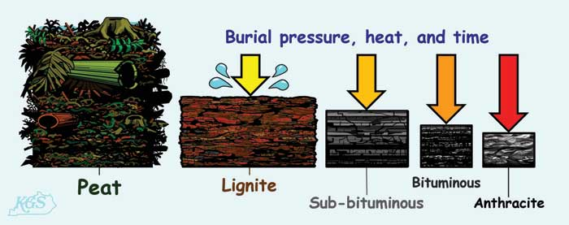
For more infomation about download this image, please click here.
The kinds of coal, in increasing order of alteration, are lignite (brown coal--immature), sub-bituminous, bituminous, and anthracite (mature). Coal starts off as peat. After a considerable amount of time, heat, and burial pressure, it is metamorphosed from peat to lignite. Lignite is considered to be "immature" coal at this stage of development because it is still somewhat light in color and it remains soft. As time passes, lignite increases in maturity by becoming darker and harder and is then classified as sub-bituminous coal. As this process of burial and alteration continues, more chemical and physical changes occur and a the coal is classified as bituminous. At this point the coal is dark and hard. Anthracite is the last of the classifications, and this terminology is used when the coal has reached ultimate maturation. Anthracite coal is very hard and shiny.
The degree of alteration (or metamorphism) that occurs as a coal matures from peat to anthracite is referred to as the "rank" of the coal. Low-rank coals include lignite and sub-bituminous coals. These coals have a lower energy content because they have a low carbon content. They are lighter (earthier) and have higher moisture levels. As time, heat, and burial pressure all increase, the rank does as well. High-rank coals, including bituminous and anthracite coals, contain more carbon than lower-rank coals which results in a much higher energy content. They have a more vitreous (shiny) appearance and lower moisture content then lower-rank coals.

http://en.wikipedia.org/wiki/Coal
Coal as fuel
Further information: Electricity generation, Clean coal technology, Coal electricity, and Global warming
Coal is primarily used as a solid fuel to produce electricity and heat through combustion. World coal consumption was about 7.25 billion tonnes in 2010^{[35]} (7.99 billion short tons) and is expected to increase 48% to 9.05 billion tonnes (9.98 billion short tons) by 2030.^{[36]} China produced 3.47 billion tonnes (3.83 billion short tons) in 2011. India produced about 578 million tonnes (637.1 million short tons) in 2011. 68.7% of China's electricity comes from coal. The USA consumed about 13% of the world total in 2010, i.e. 951 million tonnes (1.05 billion short tons), using 93% of it for generation of electricity.^{[37]} 46% of total power generated in the USA was done using coal.^{[38]}

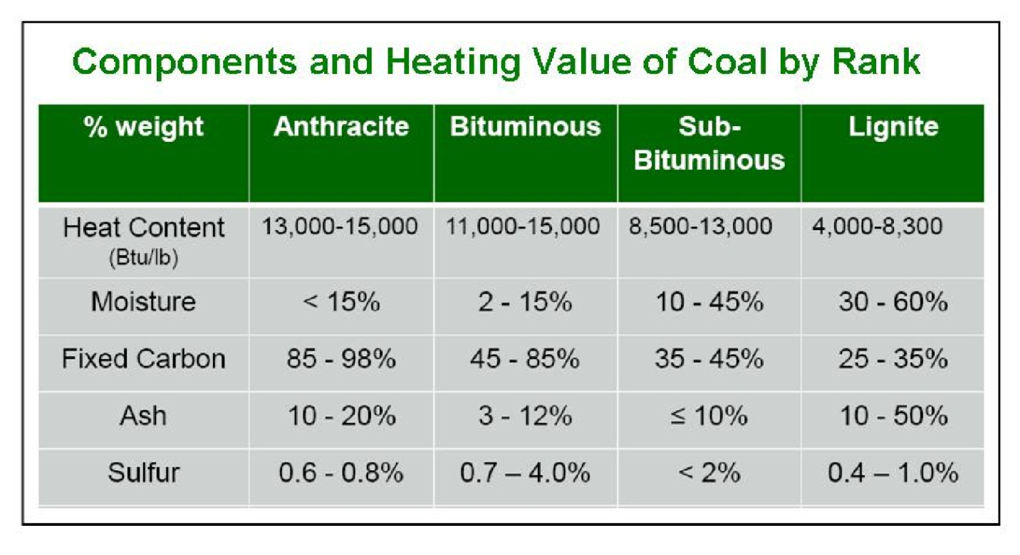
Coal Resources
DNR/DGGS SpecialReport #66: Fossil and Geothermal Energy Sources for Local Use in Alaska:
North Slope Coal: The Colville Basin may contain as much as 1/3 the total coal in the US. Possibly 3.2 trillion short tons of bituminous to subbituminous rank. Wainwright, Atqasuk, Point Lay and Point Hope are close to known outcrops of usable coal.
Cook Inlet – Susitna has an estimated 11 billion short tons of coal. The Beluga-Yentna region is estimated to contain 30 billion tons, with the Beluga Field the largest, located 45 miles west of Anchorage.
Nenana Coal province is estimated to contain 10 billion short tons of lignite and subbituminous coal.
All very low sulfur. Very low trace elements, including mercury.

Identified Alaska Coal Resources by Province
Province/Coal Field | Millions of short tons | Coal Rank
Northern Alaska Province
 |  | High-volatile bituminous & subbituminous; extensive lignite and minor anthracite
 | 150,000 | (Identified resources)
 | ~3,600,000 | (Hypothetical resources)
Cook Inlet-Matanuska Province
Beluga and Yentna fields | 10,000 | Sub-bituminous
Kenai field (onshore only) | 320 | Sub-bituminous
Matanuska field | 150 | High-volatile bituminous to anthracite
Broad Pass field | 50 | Lignite
Susitna field | 110 | Sub-bituminous
Nenana Province
Nenana basin proper | 7,000 | Sub-bituminous
Little Tonzona field | 1,500 | Sub-bituminous
Jarvis Creek field | 75 | Sub-bituminous
Alaska Peninsula Province
Chignik and Herendeen Bay fields
Unga I. | 430 | High-volatile bituminous
Gulf of Alaska Province
Bering River field | 160 | Low-volatile bituminous to anthracite
Yukon-Koyukuk Province
Tramway Bar field | 15 | High-volatile bituminous
Upper Yukon Province
Eagle field | 10 | Sub-bituminous and lignite
Seward Peninsula Province
Chicago Creek field | 4.7 | Lignite

