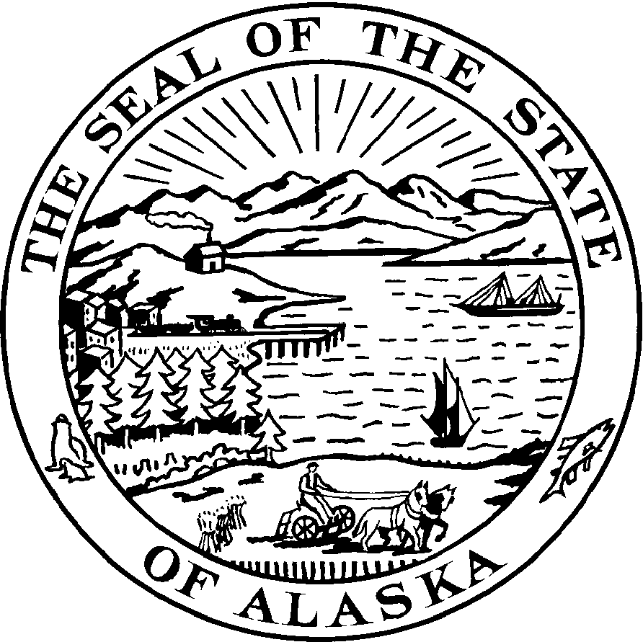

SENATOR ALBERT M. KOOKESH
ALASKA STATE LEGISLATURE SENATE DISTRICT C
E-mail: Senator.Albert.Kookesh@legis.state.ak.us
State Capitol, Room 11
Juneau AK, 99801-1182
907-465-3473
888-288-3473
FAX 907-465-2827

Sponsor Statement

SB 134

SB 134 puts the Child Support Civil Rule 90.3 guidelines into statute. In 1987, the Alaska Supreme Court enacted Civil Rule 90.3. The Supreme Court admitted this was a substantive law that the Legislature could replace at any time. In the 25 years since then, the Legislature has not replaced civil rule 90.3 with an actual law. This bill proposes to correct that long-standing deficiency.

One of the major problems with having the child support guidelines set by a court rule is the people affected by current guidelines have not had the opportunity to speak to the individuals with the power to make changes. Instead every four years they are encouraged to write letters or testify before a review committee made up of lawyers and judges who then submit their recommendations to the Supreme Court Justices who make the final decisions. With the rule in statute, individuals will have the opportunity to speak to lawmakers who have the power to make changes. Proposals to amend can be made in the future through the legislative process.

The bill proposes enactment of the current rule into statute with the exception of how the child support obligation is calculated. Currently the non-custodial parent’s support obligation is based solely on his or her income, without regard to what the other parent makes. With this bill it will be changed to an income shares model which calculates support as the share of each parent’s income estimated allocation to the child, if the original household were intact.

According to 2005 statistics (Legislative Research Report, November 2010)
- Twenty four (24) states establish their child support guidelines statutorily through their legislature while 16 states use court rule only, and 11 states use a combination of rule, commission and or agency.
- Thirty five (35) states consider the income of both parents in determining child support payments.

SB 134 changes the word court to tribunal in some cases back to court and adds number (6) to definition in Sec. 25.28.300 (page 18) to read “tribunal” means the superior court or the child support services agency created in AS 25.27.010. It also includes changes made by SB 96 addressing medical support.

The Child Support Services Division has no objections to the bill. I would appreciate your prompt and favorable action on this bill.

