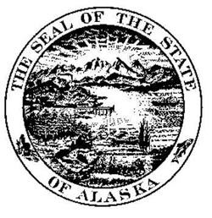
A l a s k a S t a t e L e g i s l a t u r e

Representative Anna Fairclough – House District 17

CS for House Bill 190 (FIN) (26-LS0502\N)

"An Act amending the Alaska children’s trust and relating to the trust; relating to special request Alaska children’s trust plates; and amending State Procurement Code to exempt the Alaska children’s trust and the Alaska Children’s Trust Board."

House Bill 190 establishes an Alaska Children’s Trust (ACT) grant account in the general fund and provides for private restricted-use donations, and an annual legislative appropriation of five percent average market value (preceding three years) of the trust account into the grant account. In addition it exempts the ACT and the ACT board from the state procurement code and would require the board to establish regulations as required by state statute.

It would preserve the present revenue sources of children’s trust license plates, birth and marriage certificates annually appropriated by the legislature into the grant account for child abuse and neglect prevention activities and programs.

The ACT board of directors is given the authority to enter into a joint arrangement with a non-profit entity or entities for grant-making and fundraising without delegating its duties or authority. ACT will continue to be managed by seven board of directors; including the Governor or designee, Commissioners of the Departments of Health and Social Services and Education and Early Development, four public members appointed by the Governor with expertise in children’s or prevention programs including child abuse and neglect prevention programs.

In summary, HB 190 provides ACT and the ACT board with greater flexibility to create a more stable, streamlined and simplified administrative structure that would greatly enhance the Trust’s ability to pursue its mission efficiently and effectively.

I urge your support on this piece of legislation.

