Alaska State Legislature

Chair, Judiciary
Chair, Economic Development, Trade & Tourism
Energy
Military & Veteran Affairs
Joint Armed Services
1292 Sadler Way, Suite 324
Fairbanks, Alaska 99701
Phone: (907) 452-1088
Fax: (907) 452-1146

While in Session
State Capitol, Room 118
Juneau, Alaska 99801-1182
(907) 465- 3004
Fax: (907) 465-2070
Toll Free: (877) 465-3004

House of Representatives
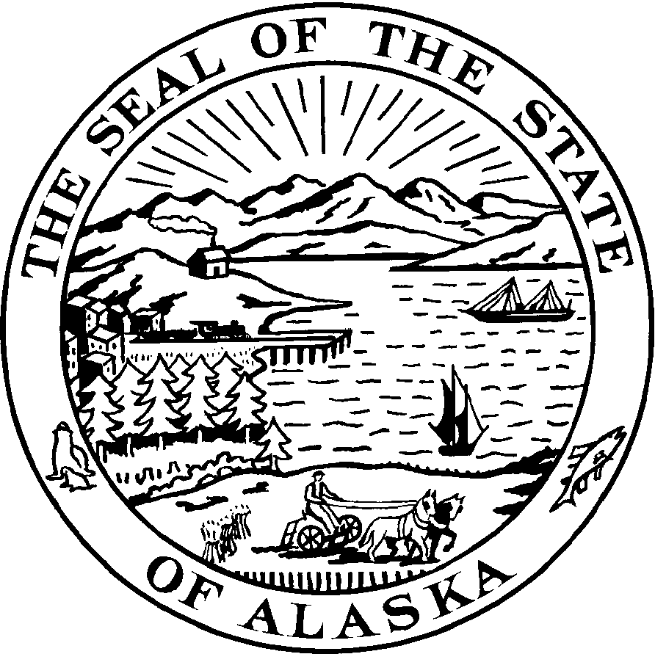

Representative Jay Ramras
District 10

Sponsor Statement
HJR 24

“Urging the United States Congress and the United States Department of Agriculture to extend the basic housing allowance exclusion to all military families for purposes of the school nutrition program.”

House Joint Resolution 24 enables military families that are living off the base to qualify for the school nutrition programs.

Families who live off the base are given an additional basic allowance for housing (BAH). Due to this increase of income children of these families are not qualified for the school nutrition programs. Many of these families are struggling financially. This presents a major issue for families that have one or multiple children to feed and a vital program such as the free lunch program is denied to them because of the location of their homes and increased income due to the basic allowance for housing.

HJR 24 encourages the United States Congress and the United States Department of Agriculture to look at the issue presented to the heroic military men and women and thus their families. This is an opportunity to ensure our military families do not have to endure additional hardships while a family member is defending our country.

