Alaska State Legislature
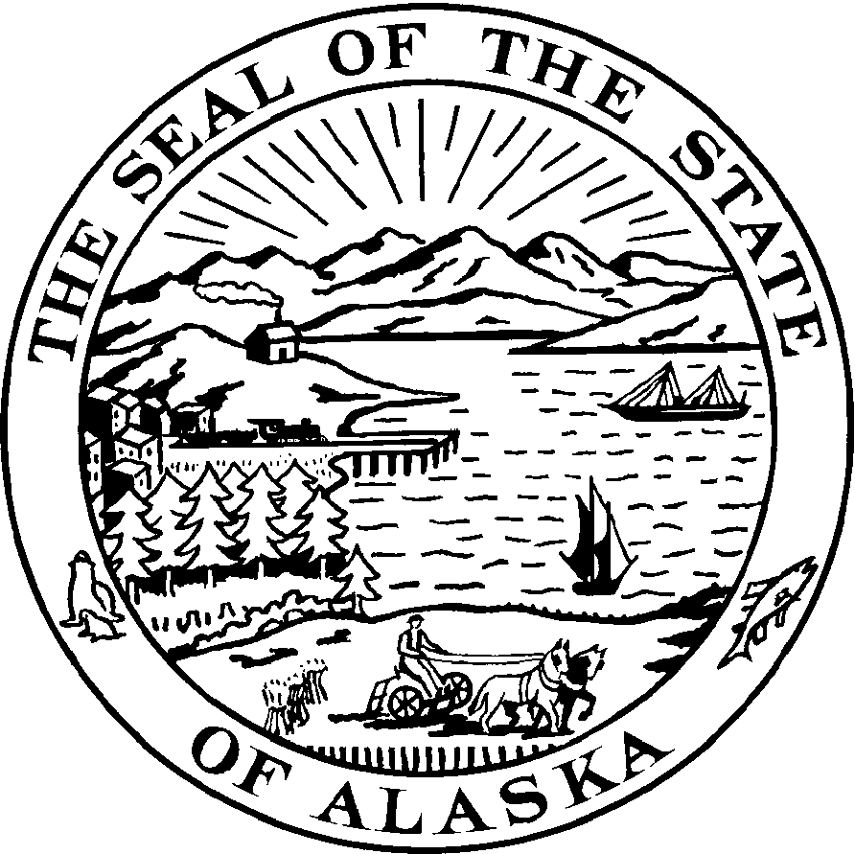
Session:
State Capitol, Room 412
Juneau, AK 99801-1182
Phone: (907) 465-3879 Fax: (907) 465-2069

Representative Charisse Millett
Chair, House Special Committee on Energy

District 30

SPONSOR STATEMENT

HB 77 - Red Cross Disaster Assistance Bill

Disasters can strike anywhere at any time. Alaska’s unique geography, small population and distance from the Lower-48 can make it even more difficult for the Red Cross of Alaska to respond to an in-state disaster.

Forty seven other states permit state employees to take unpaid time off and volunteer for the Red Cross when a disaster occurs. Alaska is one of the three states that do not.

House Bill 77 addresses this problem by permitting our state employees to join the Red Cross and use their skills to help their fellow Alaskans when a flood, earthquake, wildfire or other type of disaster hits our state.

The legislation makes Alaska more self sufficient when a disaster happens and state government benefits by having workers with this important supplemental training. Red Cross Disaster training is also provided at no cost to the state and its employees.

HB 77 is wholeheartedly endorsed by the Red Cross of Alaska.

