Alaska State Legislature

SENATOR DONALD C. olson
Chair
Community & Regional Affairs
Member
Senate Finance Committee
Ethics Committee
Legislative Council
Northern Waters Task Force
Education Funding District Cost Factor
Finance Subcommittee Chair
Fish & Game
Health & Social Services
Public Safety
Finance Subcommittee Member
Environmental Conservation
Session
Alaska State Capitol, Rm. 508
Juneau, AK 99801
(907) 465-3707
Fax: (907) 465-4821

Interim
716 W. 4th Ave. Ste 530
Anchorage, AK 99501
(907) 269-0254
Fax:(907)269-2031

Senator_Donny_Olson@legis.state.ak.us
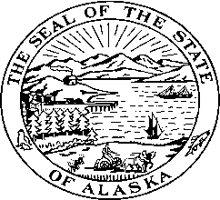

Delayed projects in Ambler due to NOA

- Airport Extension
- Replace Grizzly Bridge
- Solid Waste Site
- Riverbank Erosion in front of town
- Road construction and maintenance
- School Playground
- Future Home sites

