ALASKA STATE LEGISLATURE

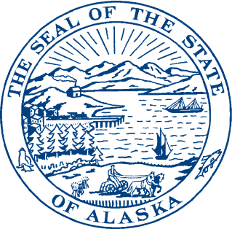
Interim:

1292 Sadler Way, Ste. 308
Fairbanks, Alaska 99701
Phone: (907) 452-1088
Fax: (907) 452-1146
Toll Free: (877) 465-3004
Session:

State Capitol Building

Room 428
Juneau, Alaska 99801-2186
Phone (907) 465-3004
Fax: (907) 465-2070
Toll Free: (877) 465-3004

REPRESENTATIVE STEVE THOMPSON
DISTRICT 10

Sectional Analysis for Sponsor Substitute for HB 289
version \I (dated 2.21.12)

Section 1. AS 38.05.096 Creates a new section under AS 38.05 that allows eligible above ground liquefied natural gas tank storage facilities, sited on state lands, to request an exemption from rental payments. The exemption could extend for up to ten years following the commencement of commercial operations as long as the facility continues to operate. Information regarding the rental exemption is deemed to be “public” and is available to the RCA upon request. A person receiving a rental exemption must adjust the storage charge downward to reflect this state benefit and pass it through to the storage customers. The intent of this new section of law is to mirror the existing benefit offered to natural gas storage operations that eligible to apply for a rental payment exemption under AS 38.05.180(u).

Section 2. AS 42.05.990(3) Amends the definition of “natural gas storage facility” and “facility” in AS 42.05.990(3) to assure that tank storage, or storage in a depleted or nearly depleted pool are afforded the same benefit that geologic natural gas storage already enjoys.

Section 3. Adds a new section to AS 43.20

AS 43.20.047. Creates a new credit for a liquefied natural gas storage facility of 1,000,000 gallons or more or an expansion of an existing facility of 1,000,000 gallons or more. The credit is capped at fifteen million dollars or 50 percent of the development cost whichever is less. This credit is in addition to any other credits for which the storage facility is eligible under this chapter. States that the liquefied natural gas storage facility must be regulated by the Regulatory Commission of Alaska and establishes how the credit or payment shall be disbursed. Sets forth how a person who has received a credit shall repay the credit if the facility ceases commercial operations within the nine calendar years immediately following the calendar year in which the facility commenced commercial operations. This section also defines “liquefied natural gas storage facility”, “ceases commercial operation” and “commences commercial operation”.

Sections 4 & 5. Make conforming amendments to accommodate the new tax credits under AS 43.20.047.

Section 6. Establishes an immediate effective date for the legislation.

