ALASKA STATE LEGISLATURE

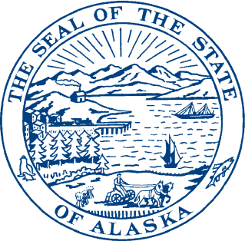
Interim:

1292 Sadler Way, Ste. 308
Fairbanks, Alaska 99701
Phone: (907) 452-1088
Fax: (907) 452-1146
Toll Free: (877) 465-3004
Session:

State Capitol Building

Room 428
Juneau, Alaska 99801-2186
Phone (907) 465-3004
Fax: (907) 465-2070
Toll Free: (877) 465-3004

REPRESENTATIVE STEVE THOMPSON
DISTRICT 10

Sponsor Statement HB 289 version I

"An Act relating to an above-ground liquefied natural gas storage facility; relating to the tax credit for an investment in an above-ground liquefied natural gas storage facility; relating to the regulation of gas storage as a utility; relating to the powers and duties of the director of the division of lands and to lease fees for a liquefied natural gas storage facility on state land; and providing for an effective date.”

The cost of energy is crippling a good portion of Interior Alaska’s economy. The ever increasing expense of heating homes and operating businesses during the long, cold, dark winter hurts the ability of Interior Alaskans to put food on the table today and plan for the future. The Fairbanks community spends over $600 million per year on space heating, pays the highest natural gas prices in the country and does not receive the state energy incentives or subsidies available to residents and communities in other regions of our state.

House Bill 289 incents the private sector’s delivery of lower cost natural gas to Interior Alaska by extending tax credits to a liquid natural gas trucking project for the Interior. A new credit for construction of above-ground liquefied gas storage tanks makes this program more flexible to fit the varying needs of gas delivery throughout the state. This legislation applies to tanked storage with a minimum volume of one million gallons. The amount of the credit is limited to 50% of construction costs up to $15 million. This allows areas of Alaska that do not have depleted gas reservoirs available, as Cook Inlet does, to receive a monetary incentive for costs associated with constructing above-ground tanks for storing LNG.

HB 289 would allow Golden Valley Electric Association, Flint Hills Refinery or another gas supplier to take concrete steps toward delivering sizeable volumes of trucked natural gas to the Interior. All money from these credits for tanked storage would be under the oversight of the Regulatory Commission of Alaska, ensuring that any savings are passed along to the rate payer thereby lowering costs and keeping more dollars in the local community.

I urge you to join me in lowering Interior Alaska’s energy costs by supporting House Bill 289.

