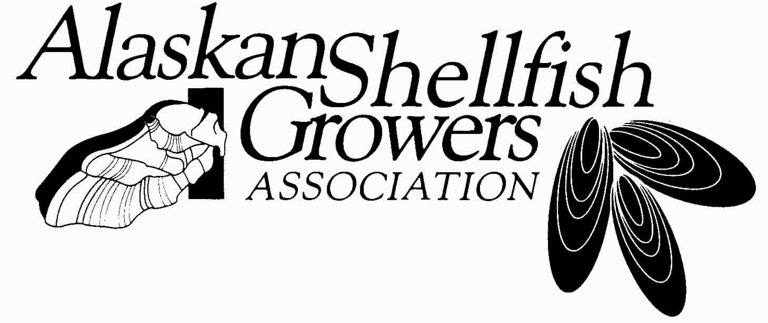

Mariculture Loan Fund (HB 121):
An Economic Development Tool

Here are some statistics pulled together from state economists that speak volumes about a social and economic crisis in rural communities in the Gulf of Alaska, particularly those adversely impacted by the collapse of the timber industry. Here are the differences in population from US Census estimates in 1996 and projections by state economists for 2030. (Only those census areas losing more than 25% of their population are included.)

- Haines -34.9%
- Ketchikan Gateway Borough -27%
- Prince of Wales/Outer Ketchikan Borough -56.6%
- Skagway-Hoonah-Angoon -62.2%
- Wrangell-Petersburg -35.3%
- Yakutat Borough -35.5%

Since these figures represent all of Southeast other than Juneau (+9.9%) and Sitka (+.1), it is little wonder the region is actively seeking to spur economic development and is leaving no stones unturned in the process. Community leaders, Native corporations and tribal governments, economic development organizations, and state and federal officials involved in these efforts agree that shellfish farming represents one of the most important opportunities for adding sustainable jobs in the region.

Southeast Alaska has been watching the growth of shellfish farming in neighboring British Columbia as inspiration. Here’s what happened over two decades as the provincial government and Ottawa put significant efforts behind developing shellfish farming:

Value of B.C. farmed shellfish $30 million
Number of farms 482
Number acres 5,300
Number of jobs (FTE) 1,585
Percentage of workers under 30 50 percent

As a result of community initiatives and industry cooperation, S.E. Alaska has added many new shellfish farms in recent years, and these initiatives and the development of training and research programs the number of new farms is expected to grow rapidly over the next decade.

That’s why groups like the S.E. Conference (a unique coalition of communities and private businesses), the Ketchikan Gateway Borough, many rural villages, Native Corporations and tribal governments, U.S. Forest Service and NOAA have all endorsed mariculture development in the Tongass.

The key roadblock to these rural small businesses is the capital and effort necessary to produce revenues that don’t begin flowing until 5-9 years after the cash begins to flow out. Imagine having to invest $125,000-$150,000 and going five years without income. Traditional business financing doesn’t fit this model, even if it’s the only way to establish a year-round sustainable job in your dying community.

That’s why Gov. Parnell’s HB 121 is perfect vehicle for overcoming this barrier. It offers Alaska residents terms up to 20 years and it delays interest and payments through an “initial period” of up to six years. These terms were patterned after the state’s private nonprofit hatchery salmon enhancement loan fund, a key component of one of the state’s most successful economic development initiative. McDowell and Associates estimates the private hatcheries in Southeast produced a direct and indirect economic value of $171 million in 2008 and supported 971private jobs. During the same year, the Prince William Sound Aquaculture Corporation is estimated to have generated $55 million in catches by the commercial salmon fleet.

HB 121 could help establish up to 30 new small businesses employing directly twice that number of residents within a year after the bill is passed. That’s a pretty good return on $3 million general fund dollars that will continue to turn over and help more Alaskans start new businesses in rural coastal Alaska. And, best of all, those businesses can still be here 200 years from now, like some oyster farms in Puget Sound.

