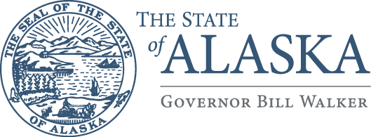
Department of
Health and Social Services

Governor’s Council on Disabilities
& Special Education

3601 C Street, Suite 740
Anchorage, Alaska 99503
Main: 907.269.8990
Fax: 907.269.8995

April 7th, 2016

Senator Anna Mackinnon
Alaska State Legislature
Capitol Building, Room 516
Juneau, Alaska 99801

RE: HB77: Disability Training and Identification Bill

Dear Senator Mackinnon,

The Governor’s Council on Disabilities and Special Education (the Council) would like to extend its support for HB 77. Your sponsorship of this bill is greatly appreciated as we feel that it will positively impact Alaska’s most vulnerable populations, including individuals with disabilities.

Individuals with a hidden Intellectual or Developmental Disability who find themselves in a situation where it is necessary to effectively communicate with an authority figure may be at a disadvantage because of communication barriers, situational unawareness, and preconceptions authority figures may hold. Sadly, there have been instances in the past where Officers of the Law were unaware of an individual’s disability and consequently misinterpreted the individual’s actions as suspect and/or criminal, resulting in either injury or imprisonment for the individual. The Council feels that a training program is needed to improve communication skills between police officers, corrections officers and parole/probation officers who interact with people who experience non-apparent disabilities, whether these disabled individuals encounter the “systems” as victims, witnesses, or alleged perpetrators.

The Council strongly supports HB77 and the awareness that could potentially be fostered by providing law enforcement officials with the proper information and sensitivity training regarding individuals who experience a disability. By implementing a training course for law enforcement officials and having the option for an individual to include a discreet marker on their state identification card that conveys their disability to an Officer, the Council believes that HB77 will greatly decrease accidents that could have been prevented in the past by increasing hidden disability awareness throughout Alaska. Passing HB 77 will provide a framework for a future in which a person’s hidden disability will not be interpreted as uncooperative or unlawful and will prevent needless misunderstandings that can lead to violence and arrest. Thank you for working to ensure that Alaskans with disabilities are safe and understood by the people that work hard to protect them.

Sincerely,
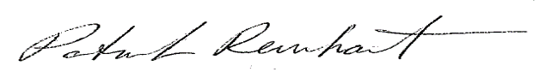

Patrick Reinhart
Executive Director
Governor’s Council on Disabilities and Special Education

