Honor and Remember origins:
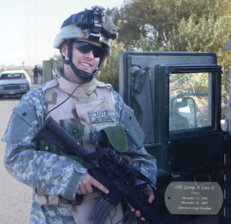 | 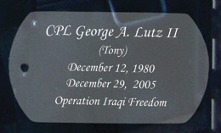  Cpl George A. Lutz II  December 12, 1980  December 29, 2005  Psychological Operations  9th Batt, Ft Bragg, NC
On December 29, 2005, George Anthony Lutz II (Tony) was killed by a sniper’s bullet while he was on patrol in Fallujah, Iraq. His family and friends endured the shock, emotional agony and overwhelming loss that accompanied the news of Tony’s death, just like the many families who have suffered the same tragedy.
In the months that followed Tony’s funeral, his father, George, visited other families who had lost loved ones in the Iraq war. He began to sense that he had joined the ranks of a unique fellowship. These families were only the latest additions to a group that originated with the American Revolution, when the first soldiers to shed their blood for our freedom gave their lives.
George found another commonality among the families of fallen soldiers. After their grief had transitioned to numbness and finally to acceptance, many families wanted to know two things: their sacrifice was not in vain and the nation would never forget. These concerns led George on a quest to discover if there was a universally recognized symbol that specifically acknowledges the American service men and women who never made it home. To his surprise, he found nothing. Thus the Honor and Remember Flag was conceived.
BELOW IS AN OPEN LETTER SENT TO THE SOLDIERS AT TONY'S SIDE THAT DAY.
Dear Downrange Soldiers,
On December 29th 2005, a snipers bullet claimed the life of our son Tony. This was the most difficult day in our family's life, I cannot imagine a more tragic one. And as difficult a day it was for us, our heart breaks for those of you who were by his side. You see we know how Tony affected lives, how much of an impression he made on everyone he touched. That day we not only lost a son, but you lost a friend and a brother. We do not know all of the facts, but we do know that he died surrounded by those who loved him.
Tony was a man who tried to lighten every situation and I am sure there were many times you could remember when he made you smile or laugh out loud. He was dedicated to his family a good husband and father and spent every available minute communicating back home. And when he was home, loving on his wife and children. Some of you remember last summer when his daughter Ava was born and how he so appreciated being given the time to leave training to be by his wife's side.
He was a good soldier, rarely complaining and excited at every phase of his training. Being a former runner he especially loved PT, accepted the challenges of AIT, language school and was particularly proud of his Army and German jump wings.

Tony strongly believed in what he was doing, believed in the mission of liberating the Iraqi people and in his relationship with you his military family. He knew why he was there and even though he fully expected to return, he was prepared for the sacrifice. We want you to know that we firmly believe that he died fighting for those beliefs, and in no way hold anyone responsible for his death. There was nothing anyone could have done to more fully protect him. War breeds casualties and many thousands of moms and dads have given their children for freedom's cause. I would like to think that Tony's death would bring an end, but we know it hasn't. Others have since given their lives and many more will most definitely follow.
We are proud that he was a soldier not only in the American army but also in the army of God. Tony had a strong faith in his savior Jesus Christ and always knew his future reward. In fact one of the last words he wrote to me was "Dad, don't worry, God is literally my shield". He knew where he would spend eternity and lived that knowledge everyday. God had a purpose for Tony's life and took him that day; nothing could have prevented it.
I know that any one of you would have willingly taken his place if possible, but conversely know this as truth, that Tony would have run to take that bullet for you. And that day he did.
His mother and I want to be sure you know that we pray for your safety everyday. Keep your eyes open, be vigilant at every moment, win that war and come back safely to your families. But especially, seek after God's purpose in your lives.
When your mission is completed please call or write, our home is open and we welcome a visit from you. We would love to hear how Tony's life or death was meaningful to you. God Bless each of you, we cannot thank you enough for your service. Courage and Honor.
Very Respectfully
George L

