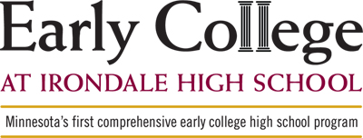

Irondale High School is the first school in the state to offer a comprehensive early college high school program allowing students the opportunity to earn a two-year associate degree for free -- all while still enrolled in high school. Irondale launched the Early College program in the fall of 2012, with full implementation in 2014-2015.

Although many high schools around the nation offer concurrent college enrollment programs -- including Irondale High School and Mounds View High School -- those programs traditionally serve the highest-achieving students in the top third of their class. And through those programs, earning an associate degree by high school graduation isn't a given.

Irondale's Early College program targets Irondale students who are in the middle of their class (30th to 70th percentile). These students, at times, have not received the preparation necessary to succeed in post-secondary programs, and they often may be the first in their family to attend college.

At the same time, the Early College program added the courses necessary for students in Advanced Placement and College in the Schools programs to earn an associate degree from Anoka-Ramsey Community College. With the Early College program, post-secondary success for all students and the opportunity to earn an associate degree will become a reality for many more students than ever before.

Students will take Early College courses at Irondale during the regular school day from credentialed Irondale teachers who are partnered with an Anoka-Ramsey Community College Faculty Mentor.

