Delaware State University

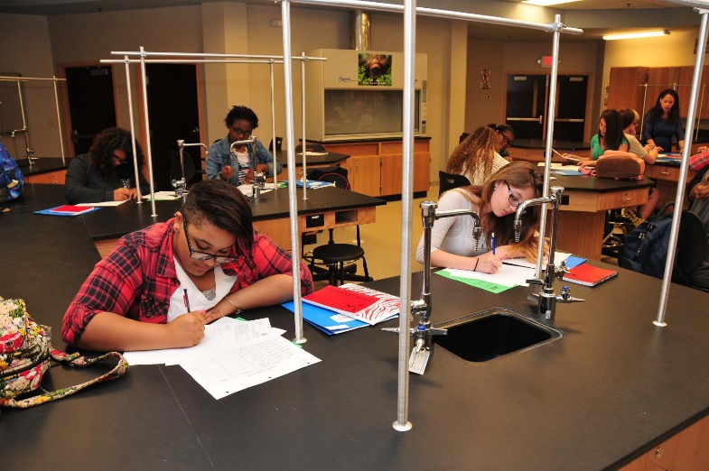

Making the Dream of College Attainable
Those who enroll in the program can earn up to 60 college credits for free while in high school, giving them a head start to complete a college education in 2 to 3 years.

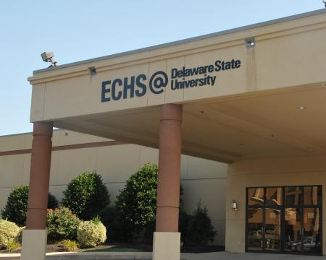
The Board of Directors of the Early College High School at Delaware State University will meet on the fourth Thursday of each month.

Board of Directors

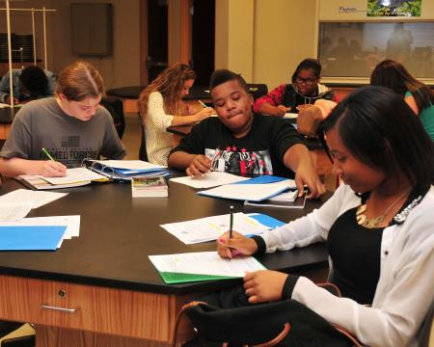
Here’s your chance to dream BIG dreams, save time and money and earn up to 60 college credits in high school.

Students

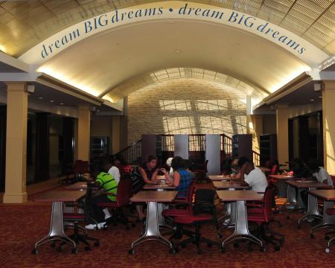
Early College High Schools provide the necessary support for first-

Parents


The Early College High School at Delaware State University is an equal opportunity employer. It does not discriminate on the basis of race, color, religion, national origin, sex, sexual orientation, marital status, disability, age or Vietnam Era veteran’s status in employment or its programs and activities. The Early College High School will not discriminate against any student in the admissions process because of race, creed, color, sex, disability, national origin or because a student’s school district of residence has a per student local expenditure lower than another student seeking admission. Inquiries regarding compliance with this policy may be directed to the Director of the Early College High School at 302.678.ECHS(3247)

