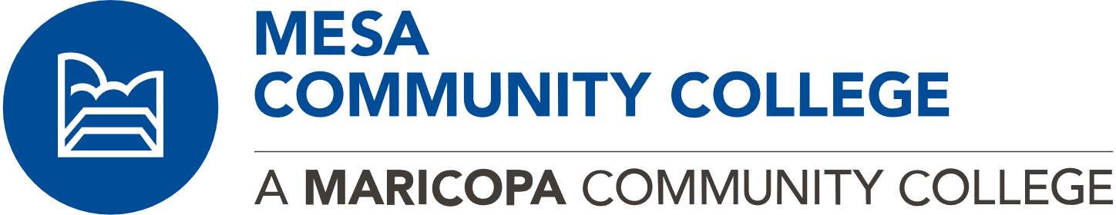

Early College Programs

What's Early College?

It's a great way to earn college credits while you're in high school!

MCC offers programs that allow eligible high school students to take courses and earn college credit while still in high school. This can save you and your family valuable time and money as you pursue a college education after high school.

Take classes at your high schoool that earn college credit (Dual Enrollment) or take classes here at MCC while you are in high school (Concurrent Enrollment).

Concurrent Enrollment

High School students take college courses at college with other college students.

Dual Enrollment

High School students take college courses in high school with fellow high school students.
We also offer ACE for qualified students and Hoop of Learning for Native American students.

Achieving a College Education (ACE)

You must be enrolled in high school and be in the 10th grade. You can apply only during the Fall semester.

Hoop of Learning

This high school to college bridge program is designed to meet the academic and cultural needs of American Indian students.

