ALASKA STATE SENATE

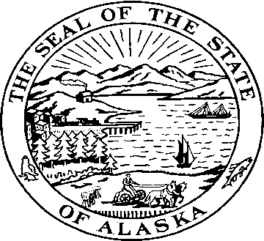

Sen. Kevin Meyer Sen. Joe Thomas
Alaska State Capitol Alaska State Capitol
Juneau, Alaska 99801 Juneau, Alaska 99801
Room 103 Room 514

Phone: 907-465-4945 Phone: 907-465-2327
Fax: 907-465-3476 Fax: 907-465-5241

SENATE EDUCATION COMMITTEE

Senators Kevin Meyer & Joe Thomas, Co-Chairs

Explanation of changes

CSSB 84 (FIN) made two changes to the Senate Education Committee bill.

The original bill contained a three-year increase in the Base Student Allocation. The FY 12 increase was $110, the FY13 increase was $115, and the FY 14 increase was $120. This was modeled on 2008’s HB 273. The Senate Finance CS removed the FY 13 and FY 14 increases.

The second change was the addition of an extension of the sunset clause for tax credits to businesses that make financial donations to secondary and post-secondary institutions. The Alaska Sea Life Center was added as an eligible institution for tax credits.

The vocational education funding factor in the Education Committee bill was left unchanged.

Prepared by Office of Senator Joe Thomas

