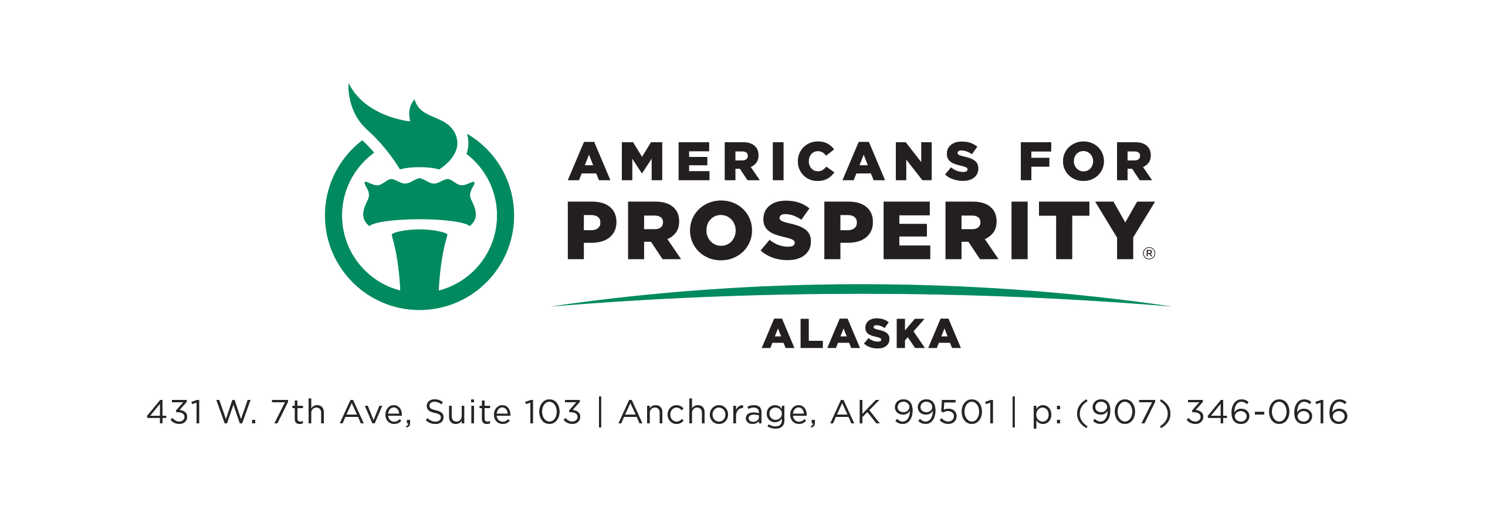
April 6, 2018

Madame Co-Chair,

My name is Jeremy Price and I am the Alaska State Director of Americans for Prosperity. We are a non-profit advocacy organization dedicated to removing barriers of opportunity and unnecessary regulations. We have offices in Anchorage and Wasilla. Thank you for removing the House passed language requiring 125 additional hours to qualify for a massage therapy license. Unlike the House passed version of HB 110, this legislation will make it easier for Alaskans to start a small business in the massage therapy profession.

Alaska has lead the nation in the unemployment rate for months. In February of this year, the Bureau of Labor Statistics put Alaska’s unemployment rate at 7.3 percent. Meanwhile, the Alaska Department of Labor has stated that Alaska lost 6,300 jobs in 2016, followed by a loss of 3,600 jobs in 2017. Now is not the time to make it harder to start a small business. We should be making it easier for Alaskans to find employment, now more than ever. Research shows that unnecessary increases in occupational licensure hurts immigrants, low-income, and minorities disproportionately. In a report put out by the Obama White House in July 2015 on occupational licensing, it states

The current licensing regime in the United States also creates substantial costs, and often the requirements for obtaining a license are not in sync with the skills needed for the job. There is evidence that licensing requirements raise the price of goods and services, restrict employment opportunities, and make it more difficult for workers to take their skills across State lines. Too often, policymakers do not carefully weigh these costs and benefits when making decisions about whether or how to regulate a profession through licensing. In some cases, alternative forms of occupational regulation, such as State certification, may offer a better balance between consumer protections and flexibility for workers.

With respect to the issue before us today, the Institute for Justice reports that 6 states do not require a license for massage therapy, while 25 states require 500 hours of training. Alaska is one of those states. With the bill before the committee today, Alaska will continue requiring the average number of hours to be a licensed massage therapist. The House passed version of HB 110 would push Alaska into one of the most burdensome states to operate a massage therapy business with a requirement of 625 hours of training. Keep in mind that the upfront cost for the training and education to get a license is roughly $14,000 and many massage therapists who get licensed, do not stay in the profession long-term. Therefore, we can see a great deal of risk in pursuing these kinds of professions.

On behalf of thousands of Alaskans struggling to get by and provide for their family, I rise in support of this legislation. Thank you for the committee’s leadership on this issue. If we make it harder for Alaskans to provide for themselves, they will be forced to turn to government for assistance. Let’s do what we can to keep that from happening.

Thank you.

https://www.bls.gov/web/laus/laumstrk.htm
http://labor.alaska.gov/trends/jan18.pdf
https://obamawhitehouse.archives.gov/sites/default/files/docs/licensing_report_final_nonembargo.pdf
http://ij.org/report/license-work-2/ltw-occupation-profiles/ltw2-massage-therapist/

