Alaska State Legislature
House Finance Committee

Representative Paul Seaton  Co-Chair  (907) 465-2689  Rep.Paul.Seaton@akleg.gov  Alaska State Capitol - Rm 505 | 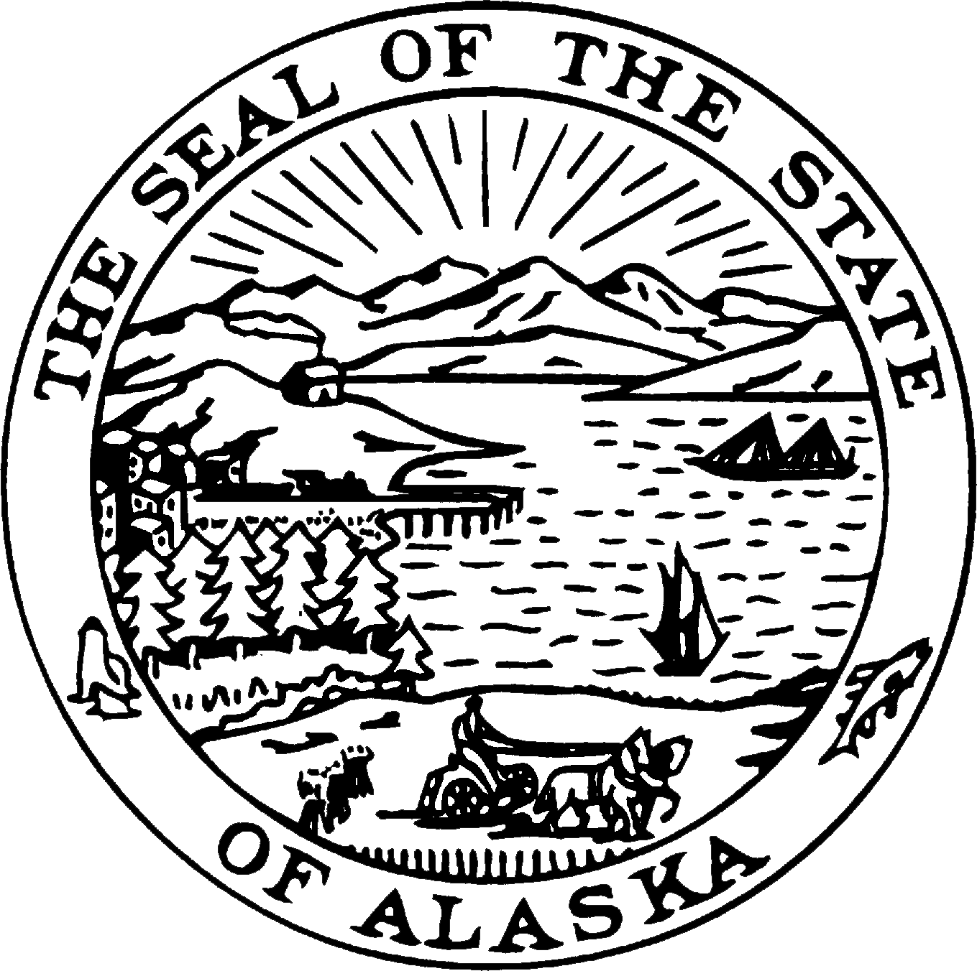 | Representative Neal Foster  Co-Chair  (907) 465-3789  Rep.Neal.Foster@akleg.gov  Alaska State Capitol - Rm 410

MEMORANDUM

DATE: January 18, 2017

TO: House Finance Members

FROM: Representative Paul Seaton, Co-Chair
House Finance Committee

RE: FY18 Operating Budget Subcommittees

This memo provides a fairly high level framework for the reviewing the operating budget by the House Finance Operating Budget Subcommittees. This process is meant to increase subcommittee members’ understanding of the responsibilities and challenges facing the departments and to prompt policy discussion and changes.

The Governor’s budget proposal includes two pieces of legislation: a Permanent Fund bill and a motor fuel tax increase bill. Without passage of the Governor’s proposed legislation or some variation of it, the budget deficit is expected to be $2.9 billion in FY17 and $2.7 billion in FY18. These deficits are calculated based upon 0.506 MBD at $46.81 per barrel for FY17 and 0.470 mbd at $54.00 per barrel for FY18. The price of ANS West Coast on January 17 was $54.83.

Given declining oil production and the low price of ANS, our task is to help chart a course for state government that strikes a balance between the level of government Alaskans need and want, and what we can afford.

Please be sure to read the Legislative Finance Division’s (LFD) Legislative Fiscal Analyst’s Overview of the Governor’s Request as soon as possible. There is a wealth of valuable information in this publication. A copy has been distributed to each HFC member, extra copies are in the 5th floor copier room 523, and you’ll also find it on LFD’s website: http://www.legfin.akleg.gov/Overview/DisplayReports.php

During the first week of session, HFC will have the following presentations:
- Wednesday, Jan. 18 Fall 2016 Revenue Forecast, Commissioner Hoffbeck & Dan Stickel
- Friday, Jan. 20 FY18 Budget Overview and Fiscal Summary, David Teal, LFD Director
Overview of the Governor’s FY18 Budget, Pat Pitney, LFD Director
During the second week of session, HFC will have department budget overviews; generally three per afternoon. The purpose of the department budget overviews is to provide an opportunity for the entire HFC to hear from department leadership about their budget, their programs and their overall performance. Key information about each program has been requested, including, but not limited to:
- Funding by funding group (UGF, DGF, Other and Federal);
- Number of PFTs, PPTs, and NP budgeted positions;
- Number of Alaskans served;
- Percentage of costs recovered through fees;
- Department assessment of the program’s importance (critical, important, beneficial, or status quo);
- Department assessment of the program’s effectiveness; and
- Whether the program is constitutionally, federally, or statutorily required.
The department HFC overview presentation helps set the stage for subcommittees to identify lower priority programs that simply can no longer be funded in our current fiscal environment. The subcommittees are not to focus on or make final recommendations regarding individual positions, specific expenditures, across the board reductions, or unallocated reductions.
Subcommittees are expected to begin their work as soon as possible. Given the new subcommittee composition, it is critical that the subcommittee chair identify subcommittee meeting topics prior to setting the subcommittee meeting schedule. Items could include, but are certainly not limited to:
- Review of the department’s program listing, with particular attention on those programs funded with Unrestricted General Funds (UGF). Are they still priority programs given our current fiscal constraints? Should they be eliminated or modified in order to save UGF?
- Indirect Expenditures – What are the priority statutory changes necessary to increase revenue?
- Other statutory changes that could increase revenue or decrease expenditures.
LFD’s Alaska Legislative Budget Handbook (the Swiss Army Knife) on pages 21- 23 includes tips for running effective subcommittee meetings, including scheduling and communicating with departments and LFD, and information about the subcommittee process. Please note, however, that some of the subcommittee information is not applicable to our new subcommittee process. For instance, subcommittees won’t have to find a meeting room as the standing/special committee meeting location will be the site for subcommittee meetings. The subcommittee close-outs will also be different as there will not be a Budget Action Sheet (BA). The final work product of the subcommittee will be a narrative report (template to be provided later) with budget amendments to be considered by HFC.

Subcommittee Administration and Operation
Meetings
Each House Finance (HFC) majority member is the chair of two or three agency budget subcommittees. This year the membership of each subcommittee is an existing standing or special committee. Minority HFC members have also been added to some subcommittees. If necessary, both HFC co-chairs may be called upon to serve as alternate subcommittee members.

With the subcommittee chair working in conjunction with the standing/special committee chair, I envision that the January and February meetings of the standing/special committee will devote at least 50% of each meeting to the subcommittee. Some departments, however, may need more subcommittee time while some may need less. In addition, some subcommittees may need to adjust the normal standing/special committees’ start times from 1:00 p.m. to 12:15 p.m. to accommodate HFC’s daily meeting schedule of 1:30 – 3:30 p.m. or extend their meeting time in the afternoon. Saturday meetings may also be an option, but we hope to minimize time changes from the regularly scheduled standing/special committees’ time slots for better public access to the subcommittee process.

If a subcommittee meeting and a standing/special committee meeting are to be scheduled back-to-back, remember to leave five or ten minutes between the meetings so the House Records secretary has time to either set up to record or to close down the recording and documents for the standing/special committee. If possible, scheduling the subcommittee first during the day may reduce the possibility of the standing/special committee not completing its agenda and having to recess for the subcommittee meeting and reconvene after the subcommittee meeting.

- Senate Floor staff is responsible for the following locations – Sergeant-At-Arms 465-4987:
  - Beltz Room 105, Thomas Stewart Legislative Office Building (TSLOB)
  - Fahrenkamp Room 203, Capitol
  - Butrovich Room 205, Capitol
- House Floor staff is responsible for:
  - TSLOB Conference Room – Micaela Bradner 465-3869 or Matt Simpson 465-6806
- House Committee Aide staff are responsible for the following locations:
  - Finance Room 519, Capitol – Jenny Martin 465-2689
  - Judiciary Room 120, Capitol – 465-4919
  - Resources Room 124, Capitol – 465-4939
  - State Affairs Room 106, Capitol – Kristin Kranendonk 465-3875
  - Transportation Room 17, Capitol – Laura Stidolph 465-4976

- The scheduling memo must be provided to the Chief Clerk by 4:00 p.m. Thursday for the following week’s meetings.
- Subcommittee chair is responsible for contacting departments and establishing the agenda.
- Create a subcommittee letterhead (a template has been provided to staff).
- Work cooperatively with agency staff and the LFD analyst assigned to the department when planning the number of and the agenda for each meeting.
  - Coordinate your meeting schedule with the Administrative Services Director of each assigned agency to take advantage of when agency staff will be in Juneau on other business and may be available for subcommittee meetings. Avoid, to the extent possible, having the agency incur travel expenses solely for subcommittee business.
  - A fiscal analyst from LFD is assigned to each agency budget and will assist the subcommittee. Please include your respective fiscal analyst in the budget process as much as possible and in any emails sent to the subcommittee and/or agency.
  - Also include the OMB analyst assigned to your department in any budget-related correspondence.
  - All subcommittee meetings must be streamed on AlaskaLegislature.TV. Use the teleconference network to request streaming of each meeting (the form below must be submitted to have the meeting streamed whether or not you actually expect to use the teleconference system) and when necessary to accommodate testifiers not located in Juneau.
    - Use this form from the Legislature’s Intranet site to schedule a teleconference:
http://intranet.akleg.gov/lio/teleconference_form.php
Call the Juneau L.I.O at 465-4648 for assistance.
- Subcommittees are strongly encouraged to incorporate public testimony into their agenda.
- Reserve the last two meetings for:
    - Draft closeout
    - Final closeout
- When necessary, schedule a pre-meeting briefing with the department the day before the scheduled subcommittee meeting to ensure that the meeting materials and presentation are what was anticipated. It is very helpful if the LFD analyst is also invited.
- Request that finalized meeting materials be provided by 5:00 p.m. the day prior to the scheduled meeting to allow for distribution to subcommittee members.
- Post all subcommittee documents on BASIS, whether prepared by members, the agency, or LFD staff.
- Subcommittee meetings are not taped or transcribed. However, a teleconferenced meeting does have an audio recording. Contact the Juneau L.I.O. to gain access.
Note: During the first week of session, meetings may be scheduled just 24 hours in advance. For subcommittee meetings to be held during the week of January 23, the signed scheduling memo must be delivered to the House Clerk’s office by 4:00 p.m., Thursday, January 19.

Resources for Subcommittee Members
To ensure that all subcommittee members have access to the same information about the department, staff is responsible for preparing a binder of information for each subcommittee member. The binder should contain at a minimum:
- This instruction memo to subcommittee chairs from the HFC operating budget co-chair.
- LFD’s Fiscal Summary, UGF Fiscal Sensitivity graphs and Approximate Balances of Reserve Accounts (from the Legislative Fiscal Analyst’s Overview of the Governor’s Budget (LFD’s Overview)).
- Other LFD statewide budget charts, if any.
- Department pages from LFD’s Overview.
- The department’s HFC Overview presentation as it will contain some department-level LFD graphs and the department’s program list.
- LFD’s Subcommittee book.
- Heads Up meeting documents, if any were provided (most departments do not).
- Operating budget detail at the department-level from OMB’s website https://www.omb.alaska.gov// or the detail budget books that includes
  - Mission,
  - Core services,
  - Measures by core services,
  - Major accomplishments,
  - Key challenges, and
  - Significant changes in results to be delivered.
- Any other communication/documentation provided by the department.
- Each department’s portion of the statewide fee report (OMB’s website).
- Each department’s pages from LFD’s 2015 or 2017 Indirect Expenditure Report.
  - The 2015 report is on LFD’s website: http://www.legfin.akleg.gov/IEBooks/2015IndirectExpenditureReport.pdf
    - Hard copies are in the 5th floor copier room 523.
    - The 2015 report includes the Departments of Commerce, Community, and Economic Development; Fish and Game; Health and Social Services; and Revenue.
- The 2017 report is found at: http://www.legfin.akleg.gov/IEBooks/2017IndirectExpenditureReport.pdf

  - It includes the Departments of Administration, Education and Early Development, Environmental Conservation, Natural Resources, Revenue (Education Credit only) Transportation and Public Facilities (AMHS Tariff Discounts/Passes only), and the Judiciary.
- The Department of Revenue prepares a biennial Indirect Expenditure report on every department. However, it is just the data and does not include LFD’s analysis. The Department of Revenue’s report is found at: http://tax.alaska.gov/programs/documentviewer/viewer.aspx?1267r
- Tabs for each of the planned subcommittee meetings that will include information provided by the department for their presentations.
There are many other additional resources available, some of which you may decide you want to include in the binders. Those resources, include, but are not limited to:
- Other information from LFD (LFD’s website, first four under the Analysis Tools tab)
  - 10-year look back graphs,
  - Budget highlights,
  - Transaction detail with notes,
  - Status of current year changes, and
  - FY17 Legislative Intent Letter.
- Legislative Audit recommendations and departmental response, if applicable (Legislative Audit’s website).
  - Other information available on OMB’s website
  - Budget Terminology,
  - UGF Reduction by Department FY15 Management Plan to FY18 Governor (called “FY2015 to FY2018 Agency Reductions, 12-15-16” on the website),
  - State Cuts and Closures to Date (December 15, 2016),
  - Operating budget detail for each Results Delivery Unit (RDU)/component from OMB’s website or the detail budget books that includes
    - Mission,
    - Core services,
    - Measures by core services,
    - Major accomplishments,
    - Key challenges, and
    - Significant changes in results to be delivered.
  - 10-Year Plan.
  - Lease – Purchase Agreements Report.
  - Personal Services Transfer Reports.
  - Links to the:
    - Department of Administration’s Comprehensive Annual Financial Report (CAFR)
    - Department of Revenue’s Revenue Sources Book Fall 2016 (and prior issues).
- Capital budget project list and detail (LFD’s or OMB’s website).

Subcommittee Requirements and Work Product
- Subcommittees are to review the numbers section of their agency budgets at a program level with the purpose of identifying programs that, given our current fiscal situation, may be ripe for elimination or modification.
- Understanding the four budget fund groups is essential to the subcommittee review process:
  - Unrestricted General Funds (UGF) – No statutory designations or restrictions on the use of these funds. Deficits refer only to UGF. Deficits do not occur in other fund groups. Accordingly UGF-funded programs will be the primary review areas.
  - Designated General Funds (DGF) – Although the Constitution prohibits the dedication of funds (with a few exceptions), the legislature has statutorily designated funds in this group for a specific purpose. Programs funded with DGF should also be reviewed as some unspent DGF fund sources lapse into the general fund.
  - Other Funds – The legislature has limited discretion (includes dedicated and duplicated funding).
  - Federal Funds – Funding received from the federal government. The legislature has limited discretion over the use of this funding.
- Language sections of the operating and mental health budget bills are not under the purview of subcommittees as my office reviews the language sections. Discuss any recommendations for language section changes with my office prior to including any language section recommendations in the subcommittee’s final closeout report.
- Any proposed changes to the comprehensive mental health program shall be discussed with Representative Gara, Chair of the Department of Health and Social Services Subcommittee, prior to incorporation in any subcommittees’ recommendations.
- Subcommittees are also to review the governor’s budget amendments that will be submitted on February 15. The HFC Assistant will deliver the relevant amendments to the subcommittee chair as soon as possible. (The amendments will also be posted on OMB’s website on February 15.)
- The subcommittee’s work is to be completed and all final reporting documents submitted to LFD and my office by 5:00 p.m., February 24, 2017. However, subcommittees that are able to do so are encouraged to close out prior to February 24. I anticipate that HFC would then take up those subcommittee recommendations before the last week of February.
  - A narrative report will be required (template to be sent out later) that describes the final recommendations of the subcommittee.
  - The final recommendations of the subcommittee may take several forms:
    - Suggested statutory changes.
    - Wordage changes. Wordage is narrative within section one (the numbers section) of the budget bill.
    - Legislative Intent. All proposed legislative intent is to be reviewed by the LFD analyst. Then discuss intent proposals with me prior to the draft closeout.
    - Budget structure changes. Work with your LFD analyst on these recommendations. As of today, we are not sure how or if this type of amendment will be accommodated by the new LFD amendment system under development.
    - Budget changes. The subcommittee chair’s staff will enter all of the subcommittee’s recommended budget changes into a new LFD amendment system. The amendment system will generate a report that will accompany the narrative report. The amendments will subsequently be considered by the full HFC. More information and training will be forthcoming when the new amendment system is finalized.
    - There will be no Budget Action Sheet (BA Sheet) this year in conjunction with this new subcommittee process.
  - The closeout narrative and all accompanying documents will be posted on LFD’s website to help the public understand the subcommittee’s recommendations and the reasons for them.

Supplemental Budget Request
- The governor’s FY17 supplemental budget request is due on the 15th legislative day, January 31. 2017.
- LFD will update their “status of current year changes” document to include Section 1 (numbers section) operating supplemental items for each department.
- Subcommittees do not take any action on the supplemental budget request.
- The governor’s supplemental request will be considered by the HFC as a whole in a format and at a time determined by the co-chairs.
- Subcommittee chairs, however, should be prepared to discuss agency supplemental requests with me and in the HFC.
We have a lot of work to do in a very short period of time. February 24, the anticipated subcommittee closeout deadline, is just Day 39 of this legislative session. I encourage you to be diligent in guiding the subcommittee work process to the development of reasonable recommendations that will garner support in the HFC and produce a budget that funds the services Alaskans need and can afford.

Please feel free to contact me or my staff, Joan Brown at 465-6587 or Arnold Liebelt at 465-6256, if you have questions or suggestions.

cc: David Teal, Director
Legislative Finance Division

Pat Pitney, Director
Office of Management and Budget

