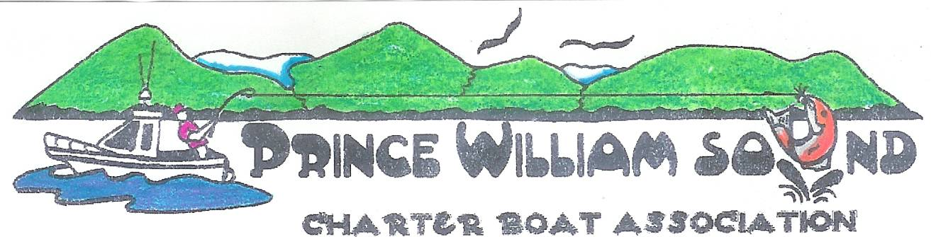
PO Box 2850, Valdez, Alaska 99686

From: Prince William Charter Boat Association
Sent: 31 March 2013
To: Senator.Kevin.Meyer@akleg.gov
Cc: Senator.Mike.Dunleavy@akleg.gov, Senator.Charlie.Huggins@akleg.gov

Dear Senators;
The Prince William Sound Charter Boat Association represents 27 charter businesses in Prince William Sound. We stand as one voice in opposition to Senate Bill 79. We submit the following concerns:
1. This proposed bill adds yet another layer of bureaucracy that adds no benefit for individual charter businessmen and women or the people we serve.
2. Adds more expense to operators already suffering with over regulation and the dollar costs of such regulation.
3. We already have one of the highest safety records in the country. No causalities period!
4. The proposed bill would all but eliminate new personal from entering the industry within a few years.
5. This bill would result in higher consumer cost over time and limit availability to safe reliable services to the average resident and consumer. The bill would encourage private boat owners with friends to take more risk to avoid the increased cost of safe reliable charter services.
6. Most importantly, this bill is drafted in an attempt to curtail the growth in guide services by a select group/groups in over crowded areas like the Kenai River. In 2011, the Charter Halibut Permit system took effect and as a result Valdez has gone from a high of 1400 charter trips in 2000 to a mere 592 in 2011. The department stated in 2004 that the current sport fish guide license requirement would “protect and improve” the state sport fishing resources. If “improving” meant the loss of nearly 6000 angler days and $2M in charter sales annually then congratulations, mission accomplished. Obviously the Valdez charter fleet would beg to differ. This bill will do nothing but drive more men and women out of the industry and add an additional layer of unnecessary bureaucracy. This bill does nothing to “assure sport fishing services compete in today’s market place” as stated in the sponsor statement when there are no fish in our rivers and fewer fish available in our oceans. If this bill is to assure the state is acting as diligent investor in the industry, then the state should prioritize the sport fish harvest. After all, sport fish harvest supports $1.4 billion on less then 1% of the total resources harvested annual. Unless this bill can prioritize personal and sport fish harvest above those of commercial harvest, sport fishing will continue to be a poor investment. The ONLY way to make this bill palatable would be to include a sport and personal use priority.

The Prince William Sound Charter Boat Association members unanimously oppose this legislation, as we have since the bill was first introduced. Wasting time fighting this legislation appears to be an annual event, please disregard and dispose SB79.

Sincerely,
//Signed//
Melvin B. Grove Jr.
President, PWSCBA
(907) 440-9148

