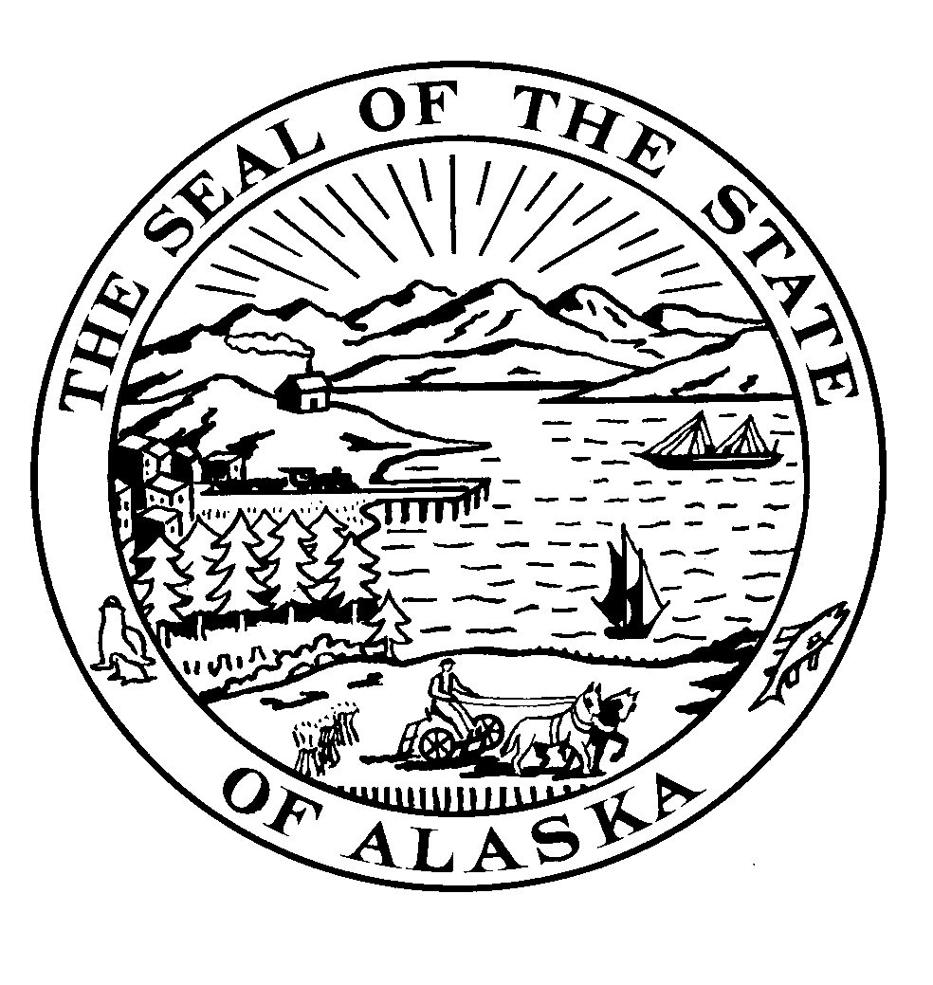
Senator Lyman Hoffman
Co-Chair, Senate Finance Committee

Room 518, Capital Building
Phone 465-4453 / Fax 465-4523

Memorandum

April 11, 2011

To: House Finance Committee

From: Senator Lyman Hoffman

Re: SB 102 Explanation of Changes

This legislation clarifies that the Department of Health and Social Services can prorate benefits under the Alaska Affordable Heating Program should it become necessary.

The Alaska Affordable Heating program was established last year and proration language was included as part of the legislation which established the program. However, the Department of Health and Social Services wanted this provision of the law to be clarified. Therefore, SB 102 is not a change in policy but a clarification of the proration language.

Specific Changes: The legislation has one section. It amends AS 47.25.623(d) to add “and C” to the law to specify that should pro rationing be necessary the Department may calculate benefits differently from the guidelines contained in the law.
Secondly, the words “on a pro-rata basis “ are added to clarify how benefits are to be calculated should it become necessary to do so.

