Alaska State Legislature

Senate Majority Leader

Judiciary Committee
Chairman
In-State Energy Committee
Co-Chair
State Affairs Committee
Joint Armed Services Committee
Legislative Council
Rules Committee

Session Address:
State Capitol, Room 119
Juneau, AK 99801-1182
(907) 465-3719
Fax (907-465-3258

Interim Address:
310 Santa Claus Lane, Ste 3B
North Pole, AK 99705
(907) 451-2963
Fax (907) 451-2332
877-465-3719

www.aksenate.org
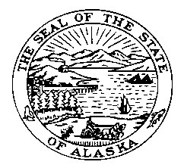

Senator John Coghill

SECTIONAL Version “P”
SSSB 47 Relating to Boarding Schools

*Sec. 1. This section removes narrow applicability to schools operating before June 1, 2005. Currently three school districts are receiving the stipend: Nenana, Bethel and Galena. The Department of Education is currently soliciting applications for three additional boarding schools statewide.

Sec. 1 also adds magnet schools that have variable-length terms but have a 180-day school year.

*Sec. 2. Section 2 increases the monthly stipend rate based on the region of the state the boarding school is located.

*Sec. 3. Section 4 allows school districts to contract room and board.

*Sec. 4. This section repeals AS 14.17.200(c) which limited DOE to approving three additional boarding school applications.

Sec. 4 also repeals AS 14.16.200(d)(2), the definition for
“district-operated statewide residential program” as Section 1 now included both statewide and district-wide residential schools.

*Sec. 5. This Act has an immediate effective date.

