ALASKA STATE SENATE
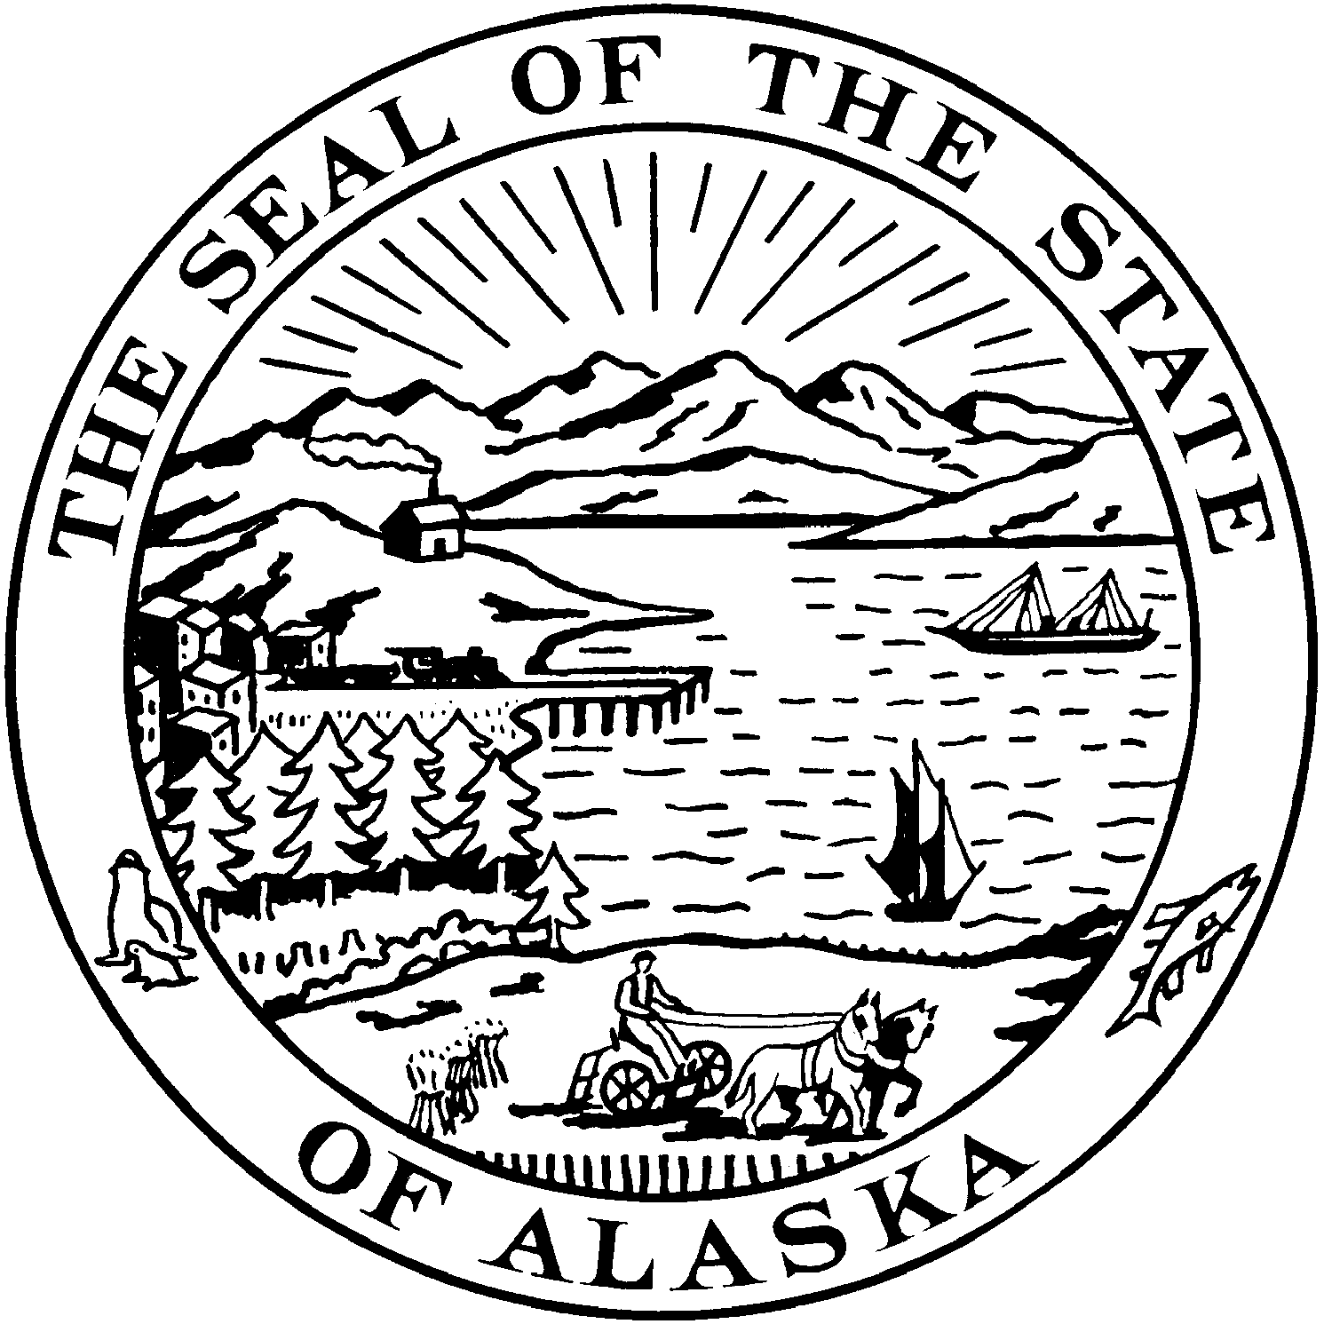
Interim: Session:
301 Santa Claus Lane State Capitol, Room 119
North Pole Plaza Mall Ste. 3B Juneau, Alaska 99801-1182
North Pole, Alaska 99705 Phone: (907) 465-3719
Phone: (907) 451-2063 Fax (907) 465-3258
Fax (907) 451-2332

SENATOR JOHN COGHILL

Senate Bill 65 – Amended Sectional Analysis – (Correction for Section 37)

Sec. 1. Asset Protection for Inherited Retirement Plans. Alaska Statute 09.38.017(a) protects an individual’s interest in a retirement plan from the claims of the individual’s creditors. The amendment extends this protection to claims of a beneficiary’s creditors (e.g., creditors of an individual’s spouse). Arizona, Florida, and Texas have enacted similar provisions.

Sec. 2. Spendthrift trusts are created for the benefit of a person (often unable to control his spending) by giving an independent trustee full authority to make decisions as to how the trust funds may be spent for the beneficiary’s benefit. A beneficiary’s creditors generally cannot reach the trust’s funds, and the funds are not actually under the control of the beneficiary.

Section 2 designates retirement plans exempt from claims under AS 9.38.017 as spend thrift trusts. However, this designation does not apply to retirement plans that fall under AS 34.40.118 (see Sec. 43).

Sec. 3. Definitional changes implementing Section 1 and expands the definition of “retirement plan” to include the Alaska teachers’ retirement, judicial retirement, public employees’ retirement, and elected public officers’ retirement systems.

Sec. 4 through Sec. 5. “Legal and equitable” added to Sec. 4 to clarify that a creditor’s exclusive remedy against an interest in a limited liability company is a charging order against the interest and other legal or equitable remedies are not available. This clarification is added to address concerns that a creditor might argue that equitable remedies are available despite the current limit in the statute. Section 5 clarifies that the rights of judgment creditors in Alaska Statute 10.50.380 applies to a limited liability company with one member.

Sec. 6. through Sec. 7. Representation for Settlement Agreements. Alaska Statute 13.06.120 provides that minors, incapacitated persons, and similar persons may be represented by another person who has the same interests in the matter. This type of representation is important in order to simplify and make more efficient proceedings that involve persons who are not legally competent to represent themselves. The existing statute clearly applies to judicial proceedings. However, often it is important to have representation of minors and incapacitated persons with respect to the settlement of accounts of trustees of trusts and with respect to settlement agreements. These amendments clarify that the statute not only applies to court proceedings but also to non-judicial settlement proceedings.

Sec. 8. AS 13.36.072 outlines the duties of a trust’s co-trustees. If the trust grants powers to some trustees over other trustees, the subordinate trustees are directed to act in accordance with the powers given to the other trustees. Additionally, the subordinate trustees are absolved of any consequences that may arise from the superior trustees.

Sec. 9 through Sec. 11. Alaska Statute 13.36.157 provides a trustee with a method to modify an existing trust, commonly referred to as “decanting”. Alaska enacted its “decanting” statute in 1998 based on a copy of New York’s statute. At the present time, the following states have enacted decanting statutes: Alaska, Arizona, Delaware, Florida, Indiana, Missouri, Nevada, New Hampshire, New York, North Carolina, Ohio, South Dakota, and Tennessee. In addition, decanting statutes are pending before Illinois, Michigan, and Virginia.

New York recently did a thorough revision of its decanting statute in 2011. The proposed amendment to Alaska’s decanting statute closely tracks the changes made by New York with modifications necessary to accommodate Alaska’s procedural provisions.

The purposes of a decanting statute are to allow a trustee to modify a trust in order to correct errors and to adjust to changed circumstances and laws. The revised draft distinguishes between trustees who have unlimited discretion and those without unlimited discretion. A trustee without unlimited discretion must maintain the same beneficiaries in the new trust and apply the same standard for distributions. The trustee cannot be a settlor or beneficiary of the trust, and has a fiduciary duty to exercise the power of appointment in the best interests of one or more proper objects of the exercise of the power and as a prudent person would exercise the power under prevailing circumstances. A trustee must exercise the power in writing and must give written notice to the settlor, any person having the right to remove or replace the trustee, and any qualified beneficiary. A beneficiary may object to the exercise if it is an abuse of discretion, or fails to comply with the trustee’s duties stated above. Restrictions exist to protect mandatory distribution rights, tax benefits, and to prohibit the trustee from exercising the power to either increase the trustee’s compensation or decrease the trustee’s liability.

Implementation of irrevocable trusts is best accomplished if the law provides reasonable flexibility to adjust to changed circumstances and to correct errors. The reason why so many states have enacted decanting statutes is because of the need for this flexibility. Amending Alaska’s decanting statute to include these revised provisions will benefit Alaskans, many of whom use lifetime or testamentary trusts to implement their estate planning purposes.

Sec. 12 through Sec. 13. If a person puts a life insurance policy into a trust, the trustee’s duties regarding investment of the life insurance policy are limited to AS 13.36.273. This provision only applies if the grantor wants the provisions of AS 13.36.273 to apply to the life insurance policy or the trustee notifies the beneficiaries that these provision will apply.

Sec. 14. Appointment of disinterested third parties is no longer consistent with modern trust practices. Current practice generally involves the appointment of family members as trust protectors. Allowing the appointment of family members further protects the trust’s beneficiary in case the original trustee is not acting in the beneficiary’s best interests.

Sec. 15. If the terms of a trust designate the trustee to follow the direction of a non-trustee advisory, the advisor may be held financially liable to the beneficiary for actions the advisor directs the trustee to take. This amendment adds another layer of protection for the trust’s beneficiary as well as the directed trustee.

Sec. 16 through Sec. 32. Amendments to 2003 Alaska Principal and Income Act. This modern act allows a person creating a new trust, or a trustee of an existing trust, to adopt a “unitrust” approach for determining the income of the trust which may be required to be distributed annually. A unitrust distributes a certain percentage of its assets annually to the current beneficiary. The use of this percentage unitrust approach allows the trustee to invest in order to maximize total return for both income and remainder beneficiaries.

Since 2003, the Internal Revenue Service has issued final regulations with respect to unitrusts. The Alaska Principal and Income Act amendments contained in this bill are designed to update Alaska's provisions to take advantage of these new regulations.

In summary, the most important changes contained in the bill expressly allow a trustee to choose a unitrust rate of three to five percent rather than be limited to the four percent amount presently in the law. The changes provide an explicit definition of income for a trust drafted as a unitrust. Language is added to provide the ordering of distributions among types of income and principal. A smoothing period of up to five years is allowed for determining the assets to be used when applying the unitrust percentage. Also, the new provisions clarify how the unitrust rules will apply to retirement benefits. These new changes will facilitate the use of unitrusts under Alaska law and maximize flexibility to take advantage of federal income tax planning.

Sec. 33 through 35. Amendments to Alaska Uniform Transfers to Minors Act. The Alaska Uniform Transfers to Minors Act allows donors, personal representatives, trustees, and obligors to transfer assets to an account for the benefit of a minor. A custodian is named who may then make distributions for the benefit of the minor. Under existing statutes, the minor is entitled to the property when the minor reaches age 18 years or 21 years, depending on the type of transfer. The statute allows this age of distribution to be extended in certain circumstances to age 25 years.

A number of situations have arisen both in Alaska and in other states where it is undesirable for assets to be distributed later than the of ages 18, 21, or 25 years due to problems the minor may have, including substance abuse problems, immaturity, and the inability to manage assets. Often the minor himself or herself is willing to have the assets remain in a custodial setting, managed by a competent person who will make distributions for the benefit of the minor. The amendments in this bill would allow for the extension to an age greater than that presently specified in the statute, as long as the minor consents to the extension during the six-month period when the minor attains the age when otherwise the assets would be distributed under the statute.

Sec. 36. Decedents Remains. Alaska does not presently have adequate statutory authority with respect to who may control the disposition of a decedent's remains. This has resulted in arguments and disputes among relatives and friends. Businesses involved in this area need protection concerning who is the person entitled to give them directions. This new act resolves the present uncertainty of the law. It provides authority for a person to provide directions and a form for a disposition document. If a person has not provided directions, then a priority list is provided of the persons who may control the disposition of the decedent's remains. Businesses that follow these directions or priority lists are protected from liability.

Sec. 37. AS 21.09.210(m) was originally written to draw large life insurance policies and millions of dollars in potential revenue to Alaska. The language intended for the first $100,000 of premium to be taxed at 2.7% and everything over the first $100,000 to be taxed at one-tenth of one percent. However, intent is not being followed when it comes to life insurance policies insuring multiple individuals. Rather than treating the policy as a single unit regardless of the number of individuals insured, the State of Alaska appears to be taking the position that life insurance policies insuring more than one individual will have their entire premium taxed at 2.7%. This interpretation places Alaska at a competitive disadvantage with states like South Dakota who tax life insurance policies based on the original intent of AS 21.09.210(m).

Section 37’s amended language brings Alaska’s treatment back in line with the more favorable treatment afforded by other states by clarifying that life insurance policies will be treated as a single policy regardless of the number of individuals insured and therefore taxed at 2.7% for the first $100,000 and one-tenth of one percent for premiums exceeding $100,000.

Sec. 38. Expands the allowable time an insurance contract may be procured on the life or body of a person with whom there is a significant financial interest in the continued life of that person being insured.

Sec. 39. Insurable Interests. For many years, individuals have relied on life insurance in helping to meet their financial, business, and estate planning needs. Often, their needs are best served by having one or more life insurance contracts held in an irrevocable trust, partnership, or limited liability company. In particular, irrevocable life insurance trusts have been widely used throughout the United States to own life insurance policies.

However, a relatively recent federal court case (Chawla, ex rel Giesinger v. Transamerica Occidental Life Ins. Co., 2005 WL 405405 (E.D. Va. 2005)) had the effect of pointing out that while state insurance statutes typically require purchasers of insurance contracts to have an “insurable interest” in the life or body of the insured, the statutory provisions describing who may have an insurable interest did not specifically include trusts and business entities which are commonly used to purchase and own such policies. This case raised sufficient uncertainty about the status of life insurance trusts that in July, 2010, the Uniform Law Commission approved amendments to the Uniform Trust Code to clarify the situation.

Alaska has previously adopted substantial portions of the Uniform Trust Code. The proposed amendment to AS 21.42.020 is based in large part on the recommended amendments to the Uniform Trust Code, and also clarifies that persons with insurable interests may form business entities for the purposes of purchasing, holding, and administering life insurance contracts. Other states, for example Delaware, have already amended their statutes for these reasons, or are considering such amendments.

Sec. 40. Language largely mirrors Section 4 by by limiting “legal or equitable” remedies of a creditor against an interest in a limited liability partnerships.

Sec. 41. AS 34.40.110 (a) allows a person who in writing transfers property in trust to stipulate that the interest of a beneficiary’s trust may not be voluntarily or involuntarily transferred prior to payment or delivery of the interest to the beneficiary. Should a trust contain a restriction described in (a), a creditor may not satisfy a claim out of the beneficiary’s interest in the trust unless the creditor is a creditor of the settlor and 1) establishes by clear and convincing evidence that the settlor’s transfer of property was intended to defraud the creditor and 2) the trust provides that the settlor may revoke or terminate all or parts of the trust without the consent of a person who has a beneficial interest in the trust. This amendment clarifies that a power to “revoke or terminate” does not include a lifetime powers of appointment or similar measures.

Section 41 also ensures statute reflects the most current IRS code.

Sec. 42. Statute of Limitation for Creditors’ Claims. Many states have decided to enact a shorter period of limitation with respect to creditors’ claims for transfer into an irrevocable trust. These states include Hawaii, Nevada, Ohio, and South Dakota. This amendment puts Alaska in line with these other states by shortening the limitation period to two years. This period is still significantly longer than other limitation periods, for example, the four-month limitation period to file a claim against and estate.

Sec. 43. AS 34.40.113 codifies the common law protection that a creditor of the beneficiary cannot compel distributions from the trust. The amendment does not however prevent a creditor from obtaining relief from a fraudulent transfer under AS 34.40.110.

Transfers of IRA Interests (AS 34.40.118). Lifetime estate planning often occurs by a participant making gifts, sales or other transfers of property during lifetime to family members or trusts for their benefit. For many individuals, one of their most valuable assets is their individual retirement account (IRA). Alaska law (AS 09.38.017) protects IRAs from claims of creditors. This protection could be construed to even prohibit voluntary transfers of the participant’s interest in an IRA, which would prevent lifetime transfers of IRAs for estate planning and other purposes. Although it is important to maintain that creditor protection for IRAs, it would be beneficial to permit voluntary transfers of IRAs. Therefore, this section clarifies that the participant of an IRA may voluntarily transfer his or her IRA during lifetime.

Sec. 44 through Sec. 48. Community Property. In 1998, Alaska enacted an optional community property system. Several amendments have been made to Alaska's act, and this bill proposes further amendments designed to improve the act. Specifically, the amendments accomplish the following:
  - Add references to a community property trust in appropriate provisions.
  - Eliminate language stating a confusing statute of limitations and incorporates by reference a new statute of limitations.
  - Provide clarification that property which spouses agree is community property is owned as community property regardless of the form of title to the property. If title to community property is in a form that provides for survivorship ownership between the spouses then the survivorship ownership is presumed to have been made with the consent of both spouses. If one spouse designates a beneficiary for an interest in property, the designation is only effective for that spouse's one half interest unless the other spouse consents in writing. Various family designations are presumed to have been made with the consent of the other spouse. The testimony of one spouse is sufficient to rebut a presumption.
  - Enact remedies for improper transfers and limitation periods within which those remedies must be pursued.
Sec. 49. Repealed sections.

Sec. 50. Indirect rule change.

Sec. 51. Applicability

Sec. 52. Requirement for two-thirds majority vote of each house.

