ALASKA STATE LEGISLATURE

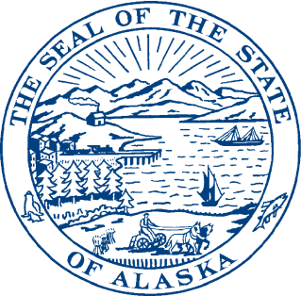
Session:

State Capitol Building Room 500
Juneau, Alaska 99801-2186
Phone (907) 465-3004
Toll Free: (877) 465-3004
Interim:

1292 Sadler Way

Room 323
Fairbanks, Alaska 99701
Phone: (907) 452-1088

REPRESENTATIVE STEVE THOMPSON
DISTRICT 3

MEMORANDUM

To: Senator Kevin Meyer
Senate Finance Committee

From: Representative Steve Thompson

Date: April 19, 2014

Re: Session Law References

Title
Sec 7 ch. 57, SLA 2003
Salmon Product Development Tax Credit

Sec 57, ch. 92, SLA 2010
Education Tax Credit

Secs. 40-42, ch. 51, SLA 2012
Film Tax Credit

Sec 22
Secs. 31-33, ch. 51, SLA 2012
Film Tax Credit

Sec 23
Secs. 3,5,7,10,14,16,18,21,23,25,28,30,32,35,37,39,42,44,46,49,51,53,55 ch. 92 SLA 2010
Education Tax Credit

Sec. 14, ch. 7 FSSLA 2011
Education Tax Credit

Sec. 15,17,19,21,23,25, ch. 74 SLASLA 2012
Education Tax Credit

Sec 24
Sec. 3, ch. 57 SLA 2003
Salmon Product Development Tax Credit
Salmon Utilization Tax Credit

Contingent Effect Section
Sec. 3 ch.57 SLA 2003 & Sec 7 ch. 57 SLA 2003
Salmon Product Development Tax Credit
Salmon Utilization Tax Credit

Sec. 4 ch. 3 SLA 2006
Salmon Product Development Tax Credit

Sec. 4 ch. 8 SLA 2008
Salmon Product Development Tax Credit

Sec. 3 ch. 102 SLA 2010
Salmon Product Development Tax Credit

Sec. 27
Sec. 42 ch. 51 SLA 2012
Film Tax Credit

Sec. 32 ch. 74 SLA 2012
Education Tax Credit

Sec 28
Sec. 57, ch. 92, SLA 2010
Education Tax Credit

Sec. 15, ch. 7, FSSLA 2011
Definition of Plant or Facility

Sec 29
Sec. 7 ch. 57, SLA 2003
Salmon Product Development Tax Credit
Salmon Utilization Tax Credit

Sec. ch.3 SLA 2006
Salmon Product Development Tax Credit

Sec. 4 ch.8 SLA 2008
Salmon Product Development Tax Credit

Sec. 3 ch. 102, SLA 2010
Salmon Product Development Tax Credit

