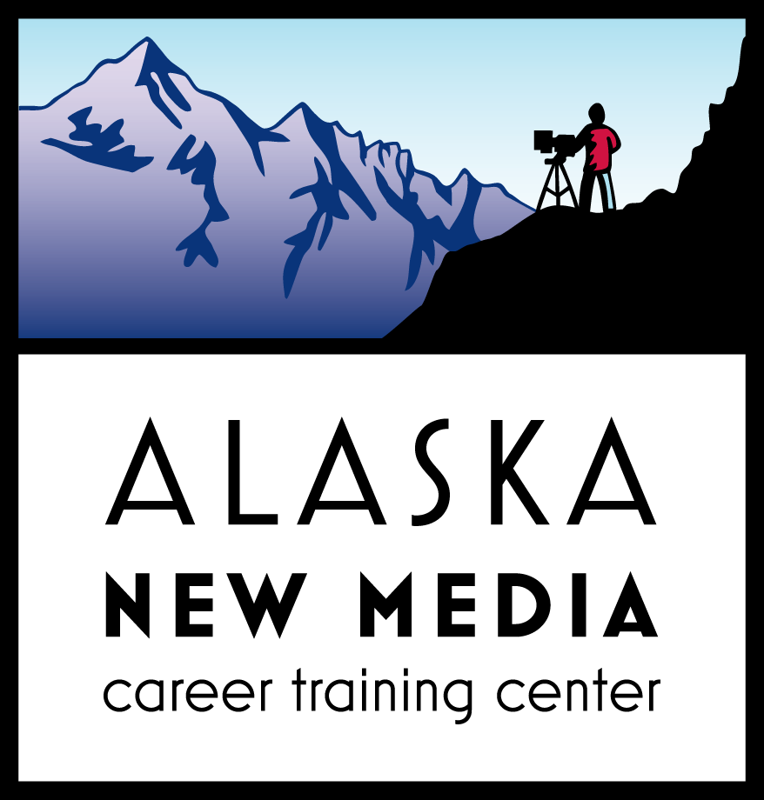

18 March 2014

Dear Senator Pete Kelly,

Alaska Crew Training is a non-profit organization committed to the training and advancement of Alaskan Crew working in Alaska’s Film Industry. To date, hundreds of students have received certificates of completion through our programs. Currently we are hosting a Producer’s Workshop; our class offerings appeal to those seeking entry-level positions as well as seasoned professionals wanting further training. We facilitate the placement of students on commercial, television and feature film projects shooting in Alaska and can cite several examples of students who have taken our program and found employment upon completion.

Recently, I attended Locations Expo which in Los Angeles. This trade show attracts film-makers considering where to shoot their next project. Almost every Producers hoping to shoot in Alaska asked me the same two questions: 1) Do you have an incentive program? And 2) Do you have a crew-base? States (and really, other countries, for that matter) that have successfully moved the needle from LA to their location intending to capture film revenue know that investing in these two areas will set a firm foundation and send a confident message to the world-wide film industry that we are a film-friendly state. Film-Incentives lead to projects, projects lead to jobs and on the-job-training, on-the-job-training leads to advancement and advancement leads to a strong, stable, healthy industry that retains local talent.

All growing industries needs time to build momentum. The Film Tax program already has a review process integrated making the proposed bill a poor fit for this industry. I implore you to OPPOSE HB306. Allow the Film Industry to stay intact through 2020. The long-term success of this industry requires stable support from the state allowing the industry a chance to grow & advance Alaskan crew, build infrastructure and create a positive impact on the Alaskan economy.

Sincerely,

Stacy Boles
Program Director
Alaska New Media

