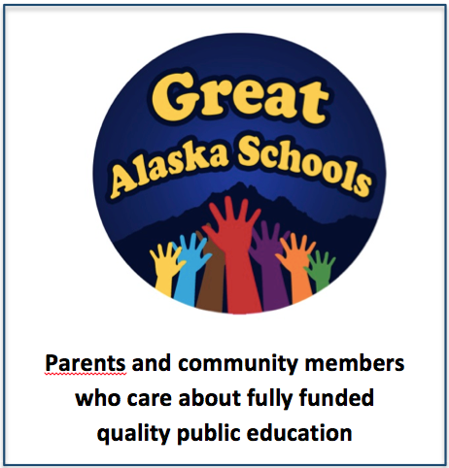
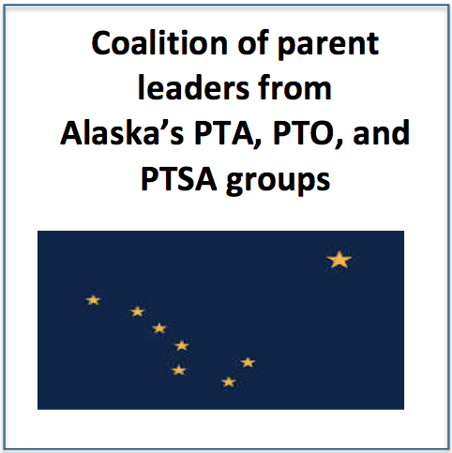

SWAV
Students With A Voice
Videos About Education Issues in Alaska
http://vimeo.com/89750203 [“cuts to great anchorage schools”]
http://vimeo.com/90070855 [“my disappearing school”]
www.tinyurl.com/AKparentparade [RELEASED TODAY: Produced by a coalition of parents]
GASA Rally Videos:
http://youtu.be/iSTM-R56gvk [1st Anchorage Rally]
https://vimeo.com/90429630 [2nd Anchorage Rally]
http://www.360north.org/gavel-archives/?event_id=2147483647_2014041064
Alaskan Nobel Prize winner Discusses Education Funding:
https://www.youtube.com/user/pacificrimmedia
Student Satire – Made By Students With A Voice:
http://m.youtube.com/watch?v=x1x38XYEd6Q
Flix Friday!
We would love to chat with you if you have any questions or would like us to know something:
Alison Arians 748-3712 and Alyse Galvin 884-2299
You don’t have to pay for cable service…
You don’t have to find a television or even go to the movie rental store…

Great Alaska Schools shares its links – Ready NOW for your viewing pleasure!

Pop the popcorn and give yourself a break!
Links will also be sent via email.

SWAV
Students With A Voice
Who we are
Great Alaska Schools: A grass-roots organization of now more than 2,000 concerned Alaskans that has sprung up in just 11 weeks to advocate for funding our public schools.
- Republicans, Independents, and Democrats
- Business owners, oil industry workers, and stay-at-home moms
- Though we are diligent and careful voters, the majority of our members have never before been actively engaged in a political cause
And
- A coalition of parent leaders from more than 50 schools and 5 school districts in Alaska who connected with each other to share knowledge and resources as a better way of bringing opportunities of success to children in Alaska
And
- SWAV - Movement of Alaskan students standing up for public education and giving their peers a voice.

Who we aren’t
- The NEA.
- Any other politically organized group.
Flix Friday!

