Alaska State Legislature
Senate Labor and Commerce Committee 2/25/13
120 E. 4th St., Juneau, AK 99801

Sent via electronic transmission to: Steve.Ricci@akleg.gov

RE: SB 55, Credit-based insurance scoring for renewals - NAMIC’s Written Testimony in Support of the Proposed Legislation

Dear Senator Dunleavy, Chair; Senator Micciche, Vice-Chair; and members of the Senate Labor and Commerce Committee:

Thank you for providing the National Association of Mutual Insurance Companies (NAMIC) an opportunity to submit written testimony to the committee for consideration. NAMIC is the largest and most diverse property/casualty trade association in the country, with 1,400 regional and local mutual insurance member companies serving more than 135 million auto, home, and business policyholders and writing in excess of $196 billion in annual premiums that account for 50 percent of the automobile/ homeowners market and 31 percent of the business insurance market. More than 200,000 people are employed by NAMIC member companies. NAMIC has 85 members who write property and casualty insurance in the State of Alaska, which represents 41% of the marketplace.

Unfortunately, I will be unable to attend tomorrow’s committee hearing, because of a prior professional commitment at another state legislature. Please accept this written submission as testimony for the committee hearing. The letter need not be read into the hearing record, but NAMIC would greatly appreciate having this letter referenced as a submission in support of SB 55.

On behalf of NAMIC’s members, we respectfully support this pro-insurance consumer, pro-insurance underwriting and rating accuracy, and pro-market competition legislation for the following reasons:

1) SB 55 is pro-insurance consumer- The current credit-based insurance scoring (CBIS) law restricts an insurer’s ability to use a consumer’s CBIS at the time the insurance policy is renewed. This limitation upon an insurer’s ability to underwrite and rate their current policyholder in a manner consistent with the policyholder’s initial application for insurance adversely impacts a majority of insurance consumers.

Insurance industry studies, both nationally and Alaska specific, have repeatedly found that the vast majority of insurance consumer directly benefit from the use of CBIS in the rating and underwriting process, and see lower insurance rates as a result of the use of CBIS.

There are a significant number of studies that have evaluated the beneficial impact CBIS has on insurance premiums, and they all reach the same conclusion - most insurance consumers benefit from the use of this fair, equitable, and predictive risk of loss exposure underwriting tool.

For example, in June of 2009, the Arkansas Department of Insurance reported that, “87% of consumers either received a discount for credit or it had no effect on their premium” and “[f]or those policies in which credit played some role in determining the final premium, those receiving a [premium] decrease outnumbered those who received an increase by 3.21 to 1.”

In Alaska, a recent industry study (the PCI report), concluded that the current CBIS law that restricts the use of CBIS in the renewal process has resulted in premium increases for a significant number of insurance consumers. SB 55 would allow insurers an opportunity to provide insurance consumers with the benefit of having their CBIS used in the renewal process.

Moreover, 2012 CBIS trend data from FICO (formerly known as Fair Isaac) demonstrates that credit-based insurance scores for consumers in Alaska have been stable or have slightly improved for most consumers over the last five years, even during this down-turn in the economy. (See attached Fair Isaac Standard Auto and Homeowner’s Insurance CBIS Trend Summary Charts). Consequently, it is in the best interest of most insurance consumers to have their insurer consider their recent CBIS score at their policy renewal.

2) The proposed legislation is pro-underwriting accuracy – The basic principle of insurance is risk of loss transfer from policyholder to insurer. The insurance company accepts the policyholder’s particular risk of loss exposure in exchange for the payment of an insurance premium. In order for this risk transfer to be fair and equitable for both parties, it must be based upon a complete and accurate actuarial assessment of the risk of loss exposure of the consumer. The need for a thorough evaluation of the consumer’s risk of loss exposure is necessary at both the time of initial application for insurance and at each subsequent renewal of the policy, so that the consumer receives a rate that accurately reflects the consumer’s current risk of loss exposure.

The evidence in support of the validity and reliability of CBIS as a predictor of claims frequency and severity is beyond refute. All of the federal studies, state department of insurance studies, and independent academic studies have found that CBIS is an extremely predictive underwriting tool.

In the 2007 Federal Trade Commission Report to Congress, “Credit-based Insurance Scores: Impacts on Consumers of Automobile Insurance”, the FTC, after evaluating over 2 million policies, concluded that “credit-based insurance scores are effective predictors of risk under automobile policies. They are predictive of the number of claims consumers file and the total cost of those claims. The use of scores is therefore likely to make the price of insurance better match the risk of loss posed by the consumer.”

Insurance consumers want, need, and deserve to have insurance rates that are commensurate with the consumer’s personal risk of loss exposure, not just when they initially apply for the insurance, but at each and every renewal of the insuring agreement. SB 55 will assist insurers in their on-going commitment to provide consumers with rates that are fair and accurate.

3) SB 55 is pro-market competition – Under the current law, insurance consumers are penalized for staying with the same insurance company because of the restrictions on the use of CBIS on policy renewals and are forced to switch insurers so that the policyholder can continue to reap the benefits of CBIS in the rating and underwriting process. SB 55 would allow all insurers, including the policyholder’s current insurer, to use CBIS in the renewal process. This will stimulate robust pro-consumer market competition between insurers, which will provide consumers with more insurance product price-points to consider.

For the aforementioned reasons, NAMIC respectfully requests that committee members VOTE YES on SB 55.

Thank you for your time and consideration of NAMIC’s written testimony. Please feel free to contact me at 303.907.0587 or at crataj@namic.org, if you have any questions pertaining to my written testimony.

Respectfully,

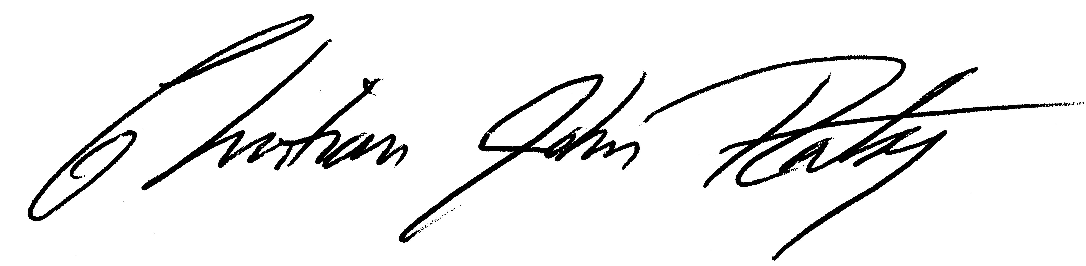

Christian J. Rataj, Esq.
NAMIC’s Western State Affairs Manager

