Green = Comprehensive smoke-free workplaces ordinances in place

Yellow = Sitka has an exemption for bars in stand-alone buildings, but all other workplaces are covered

Orange = Boroughs without the authority to pass smoke-free workplace ordinances on the local level due to lack of health powers

Gray = Legal analysis not conducted, but likely in the same category as the orange-shaded boroughs with inadequate health powers to enact smoke-free

Borough |  | Borough seat | Class |  |  |  | Population | Area | Map
Aleutians East Borough |  | Sand Point | Second |  |  |  | 3,141 | 6,988 sq mi  (18,099 km²) | 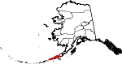
Anchorage |  | (Consolidated  city-borough) | Unified Home Rule |  |  |  | 291,826 | 1,697 sq mi  (4,395 km²) | 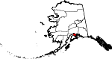
Bristol Bay Borough |  | Naknek | Second |  |  |  | 997 | 505 sq mi  (1,308 km²) | 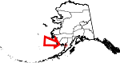
Denali Borough |  | Healy | Home Rule |  |  |  | 1,826 | 12,750 sq mi  (33,022 km²) | 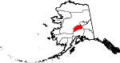
Fairbanks North Star Borough |  | Fairbanks | Second |  |  |  | 97,581 | 7,366 sq mi  (19,078 km²) | 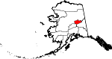
Haines Borough |  | (Consolidated  city-borough) | Home Rule |  |  |  | 2,508 | 2,344 sq mi  (6,071 km²) | 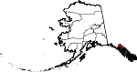
Juneau |  | (Consolidated  city-borough) | Unified Home Rule |  |  |  | 31,275 | 2,716 sq mi  (7,034 km²) | 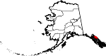
Kenai Peninsula Borough |  | Soldotna | Second |  |  |  | 55,400 | 16,013 sq mi  (41,473 km²) | 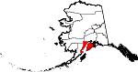
Ketchikan Gateway Borough |  | Ketchikan | Second |  |  |  | 13,477 | 4,840 sq mi  (12,536 km²) | 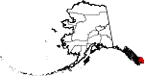
Kodiak Island Borough |  | Kodiak | Second |  |  |  | 13,592 | 6,560 sq mi  (16,990 km²) | 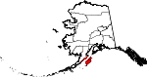
Lake and Peninsula Borough |  | King Salmon | Home Rule |  |  |  | 1,631 | 23,782 sq mi  (61,595 km²) | 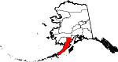
Matanuska-Susitna Borough |  | Palmer | Second |  |  |  | 88,995 | 24,682 sq mi  (63,926 km²) | 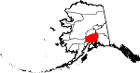
North Slope Borough |  | Barrow | Home Rule |  |  |  | 9,430 | 88,817 sq mi  (230,035 km²) | 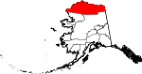
Northwest Arctic Borough |  | Kotzebue | Home Rule |  |  |  | 7,523 | 35,898 sq mi  (92,975 km²) | 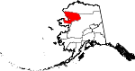
Sitka |  | (Consolidated  city-borough) | Unified Home Rule |  |  |  | 8,881 | 2,874 sq mi  (7,444 km²) | 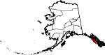
Skagway |  | - | First |  |  |  | 968 | 452 sq mi  (1,171 km²) | 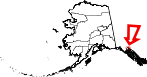
Unorganized Borough |  | - | - |  |  |  | 78,149 | 323,440 sq mi  (837,706 km²) | 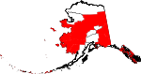
Wrangell |  | (Consolidated  city-borough) | Unified Home Rule |  |  |  | 2,369 | 2,570 sq mi  (6,656 km²) | 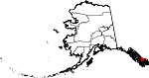
Yakutat |  | (Consolidated  city-borough) | Home Rule |  |  |  | 662 | 7,650 sq mi  (19,813 km²) | 