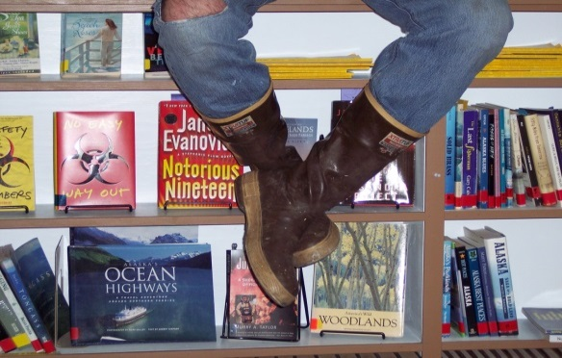

OUR NEW
COFFMAN COVE COMMUNITY
LIBRARY

The Coffman Cove Community Library was established in 2002 by the City of Coffman Cove.
It’s collection of over 16,000 items resides in a 2,360 square foot modular structure that was
originally part of a logging camp, was moved over water to its’ current location in the 1960’s
and was formerly a schoolhouse. The facility does not meet the community’s library needs and
its condition is such that it is not economical to expand or repair it.
This project is to provide a purpose-built library that meets the needs of the community, is
economical to operate and will allow the library to offer expanded hours of service. The facility
is envisioned to be single story, 3,100 square feet in size, and include new capabilities such as a
multi-purpose room, a segregated Children’s Area and a designated Teen Area. It is to be
located on an existing foundation that will become part of a “Civic Mall” where the City plans to
consolidate the Post Office, Clinic, and City Hall offices.
A concept design has been developed for the specific site and existing foundation. It
demonstrates how the library can fit into the community’s “Civic Mall” concept. The estimated
project cost is $2,216,000 and includes the value of the site, existing utilities, parking,
foundation and the ground source heat pump well field. The City has applied to the State of
Alaska for matching construction grant funding and plans to raise the rest locally and through foundation grants. The estimated operating cost of the library is expected to be reduced due to the ability to tap into a ground source heat pump system and the reduction of constant maintenance costs due to the age of the existing facility.
Coffman Cove Community Library Project Schedule
- 2013
Participate in Pre-D Program
Apply for Matching Grant
Rated as #2 Library Project

- 2014
Continue Fund Raising
Design

- 2015
Construct

- 2016
Place facility into service

An Educated Society is a An Educated Society is a Society that can Flourish.

The “Civic Mall” plan allows the Library and City offices to share spaces that include the lobby, multi-purpose room, toilets, janitor closet, mechanical and electrical support spaces and parking.
PROJECT GOALS
- Provide an attractive & healthy space to meet the varied educational and communication needs of community members and visitors.
- Increase library open hours.
- Create a beautiful and accessible library for our community to enjoy far into the future.
- Enhance community engagement.
- Save energy costs.
- Respond to current and future needs of our community

