5 April 2014

To: Alaska Senate Finance Committee
From: ABR, Inc.—Environmental Research & Services (ABR)
RE: Testimony by Mike Wood on 3 April 2014

Dear Senators:

On 3 April 2014, Mike Wood of Chase, Alaska provided testimony to your committee regarding the proposed Susitna/Watana Project. We obtained an audio copy of Mr. Wood’s testimony and would like to inform the Committee that Mr. Wood was incorrect in asserting that scientific equipment was illegally installed and subsequently removed on private lands in the proposed project area.

ABR, Inc., is one of AEA’s prime contractors on the Susitna/Watana Project. We manage a number of subcontractors, including GW Scientific (GWS), who employed Mike Wood in 2012 and 2013 as a field technician. In this capacity, Mr. Wood assisted other GWS staff with the installation and removal of scientific monitoring equipment. After hearing Mr. Wood’s accusation of permit violations and illegalities, ABR initiated an internal inquiry with GWS and Solstice Alaska Consulting, Inc., who is our permitting subcontractor for the Susitna/Watana Project. Because Mr. Wood did not provide the Committee with any specifics regarding when and where the alleged illegalities and permit violations occurred, we will not try to guess what he was referring to. We can state without qualification, however, that at no time was any scientific equipment deployed by GWS out of compliance with valid permits. We can provide the Committee with extensive documentation for the permits associated with every piece of scientific equipment that GWS deployed on the Susitna/Watana Project and, therefore, can demonstrate that Mr. Wood’s testimony was inaccurate and not properly informed.

ABR, Inc., has operated in Alaska for 38 years on a wide variety of projects on public and private lands, and we have developed policies and procedures to assure that any work we conduct has the proper permits. In addition, Solstice Alaska Consulting, Inc., was added to our team as permitting experts to assure that all of our subcontractors also were 100% in compliance with all land access and permitting issues. Again, if requested, we will provide the Committee with extensive permit compliance documentation.

Mr. Wood also made a number of negative comments about the scientific program being conducted for the Susitna/Watana Project. Because our reputation is critical to our business and that of our subcontractors, I feel compelled to respond to some of those comments. Specifically, Mr. Wood questioned both the quality and quantity of the data being collected for the project. In terms of data quality, AEA has assembled a team of experienced Alaskan prime contractors, including ABR, who in turn have developed multidisciplinary teams of subcontractors who are some of the best in the country for working on these types of projects. Each study and sampling effort has been carefully designed and approved by the Federal Energy Regulatory Commission to provide the very highest quality of data. Further, all data collected are subjected to a rigorous three-stage Quality Assurance/Quality Control (QA/QC) process before they can be used in any analysis or in any report.

Page 2
4 April 2014

In terms of the quantity of data that have been collected, the amount of data that have been collected during the first full year of study (2013) alone is extensive with much of it already available through the Geographical Information Network of Alaska. The FERC-approved study plans call for the collection of at least one more year of data followed by an extensive evaluation of project effects. These current data will be complemented by extensive sets of Susitna River data and reports that were prepared for Susitna Hydro studies over a five-year period during the 1980s. AEA has compiled all of those reports and made them available through the Alaska Resources Library and Information Services (ARLIS). In combination, the total amount of information that is available and that will be used for evaluating project effects and establishing Protection, Mitigation, and Enhancement measures is unprecedented.

Although we respect Mr. Wood’s right to testify about his personal opinions regarding potential project impacts, it is not accurate for him to portray himself as an informed project scientist. Please contact me if you would like us to provide specific documentation for anything I have covered in this letter.

Respectfully,

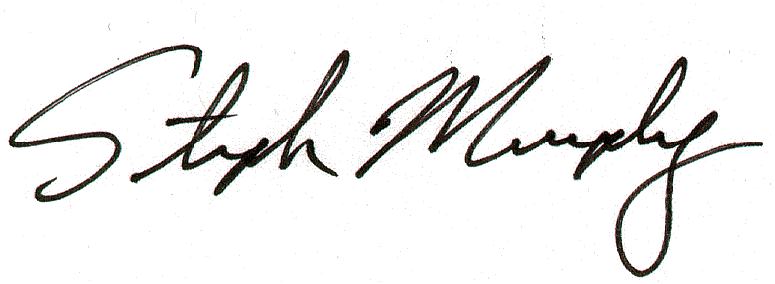
Stephen M. Murphy
President

