Alaska State legislature

Senator Lyman Hoffman, Co-Chair
State Capitol, Room 518
Juneau, Alaska 99801-1182
Phone: (907) 465-4453
Sen.Lyman.Hoffman@akleg.gov

Senator Anna MacKinnon, Co-Chair
State Capitol, Room 516
Juneau, Alaska 99801-1182
Phone: (907) 465-3777
Sen.Anna.MacKinnon@akleg.gov

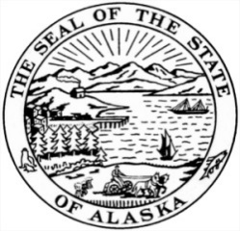
SENATE FINANCE COMMITTEE

House Bill 222
Letter of Intent

It is the intent of the Alaska State Legislature in extending the transition period established by section 13(a), ch. 27, SLA 2015 that the Board of Barbers and Hairdressers work with the Alaska State Legislature and licensees to recommend appropriate licensing and renewal standards for manicurists before the end of the transition period that:
- protect the health of Alaskan consumers;
- do not place an undue burden on existing licensees who are operating safely;
- ensure reasonable access to any required education for existing licensees;
- respect the diversity of employees in the field; and
- do not provide a barrier to entry to new licensees.

Adopted by the Senate Finance Committee
May 15, 2017

Senator Anna MacKinnon Senator Lyman Hoffman
Co-Chair, Senate Finance Committee Co-Chair, Senate Finance Committee

