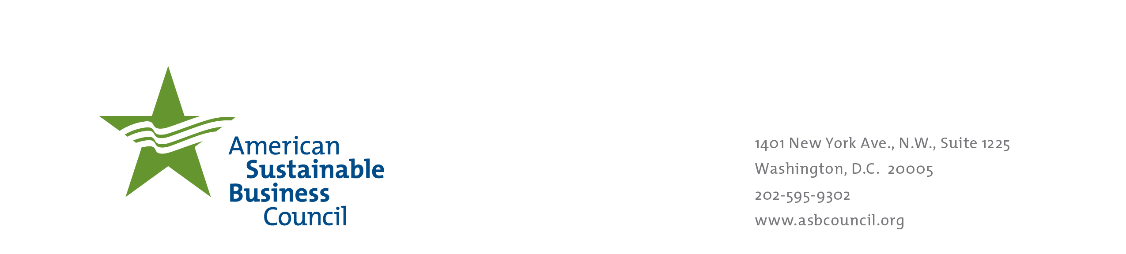
Testimony in Support of
the Toxic Free Children’s Act (SB 151)

February 19, 2014
Alaska Legislature
Health and Social Services Committee

Re: Support SB 151

The American Sustainable Business Council is pleased to submit this letter in support of the SB 151, the Toxic-Free Children’s Act.

The Council is a growing network of business organizations and business including businesses in Alaska committed to advancing a new framework and policies that support a vibrant and sustainable economy. Today, the organizations that have joined this partnership represent over 200,000 businesses.

ASBC believes that keeping toxic chemicals out of everyday household products, particularly those made for infants and children, makes good business sense. With appropriate government policies, laws, and regulations, there is even more potential to boost the economy while protecting the environment and public health.

Too often there are voices taking positions about that they say are “good for business” when their positions are at the expense of what’s good for people and what’s good for the natural environment. We at the ASBC believe that that is a false choice. A growing number of businesses of all sizes are making choices that are good for people and good for the environment because it is good for their financial bottom line.

Let me tell you about one example. Barry Cik is the founder and CEO of Naturepedic, a mattress manufacturer. He says, “Making products with chemical laden highly flammable ingredients, and then adding even more chemicals in the form of ‘flame retardants’, only provides a false sense of security. These flame retardant chemicals are less, not more, safe. They provide almost meaningless protection, and instead only add to the toxic chemical burden.” In describing his business, Barry says “Naturepedic creates its products with safer, less flammable components to begin with. For example, organic cotton is nowhere near as flammable as other common filling and cushioning materials.”

“Years ago, the most prevalent attitude was that if a product was on the shelf, it was safe because if it wasn’t safe, the government wouldn’t allow it to be sold. Today, people are realizing that this simply is not the case.” Clarity in the marketplace is exactly what we can create with good legislation, such as SB 151.

The businesses and business organizations we represent make the choices for various reasons:
- Our customers want products that don’t expose them and their children to toxic chemicals. When people know that a product contains toxic chemicals, they often switch to products that contain less toxic or non-toxic ingredients.
- Government sets rules in the marketplace that help signal to businesses what the constraints and opportunities are. We businesses respond to those signals, another reason our businesses choose to do what is right by business and what is right by people’s health and the environment. We are choosing to reduce the costs and risks, especially product liability associated with managing toxic chemicals in products across supply chains. We are also choosing to make, buy, and sell healthier, greener products.
- Many of our businesses are Main Street businesses. We see our customers face to face. Our business owners and entrepreneurs want to look their customers in the eye when they say “thank you for purchasing that crib for your newborn” -- and know that they aren’t also selling them risky chemical residues, emissions, and materials. We are choosing to “go beyond compliance” to do what is right by our businesses and what is right by people’s health and the environment.
- We want to do right by our employees and not expose them to toxins in the workplace, which will only result in lost work days and productivity at a financial cost to our businesses.
- We realize we are part of a complex, interdependent economy, society and world. Our businesses know that everyone, including them, bears a portion of the cost of externalities (costs not borne by those who generate them) like poor health and environmental contamination. We want to reduce the drivers of those costs, economy-wide, so that the costs go down.

Our businesses that are making the choice to do what is right for them and right by human health and the environment are competing with businesses that are making choices that are in their narrow self-interest and too-little, if at all, factor health and environmental effects into their business decisions.

Business is creative and innovative. When we have good information and clear signals, we create and innovate products and product formulations that reflect the constraints and opportunities that the market and its rules present to us. We believe there is an important role for government to do more to provide clear signals and ensure that businesses and our customers have good information. We would like your help with the following:

- Create a level playing field for our businesses that choose to manufacture, distribute, and sell products to children that are free from unnecessary “flame retarding” and other toxic chemicals. We don’t want to sell these toxic chemicals to children through products bought by their parents. We want rules that keep them from being put in products in the first place. This will help our businesses compete on level ground with those businesses that are not choosing to factor human health and the environment as much as we do into their business decisions.
- We want disclosure requirements that let intermediate manufacturers, distributors, retailers, employees, and consumers know what is in the products we are handling and buying so we can have the information that we need to choose which products to buy, use and sell to our customers. We want to see improved transparency and communication throughout our supply chains.
- We want rules that contribute to the expansion of markets for safer and greener products. Government policy that limits and identifies hazardous chemicals, and requires disclosure to the public of their use in products enables product makers to favorably differentiate themselves in the marketplace.

Thank you again for the opportunity to be heard on these important business issues.

Sincerely,
David Levine
CEO and Co-founder
American Sustainable Business Council
dlevine@asbcouncil.org
(202) 595-9302 Ext. 101

