February 4, 2013

Representative Paul Seaton
State Capitol
Juneau, AK 99801

Re: HB 89

Dear Rep. Seaton:

While ASGA supports the intent of HB 89, we are uneasy that it could potentially allow a state agency to be held harmless when unilaterally deciding to destroy private property.

Specifically, 16.05.093(f) holds the State of Alaska harmless if the Alaska Department of Fish and Game (ADFG) unilaterally decides it is necessary to destroy a crop of shellfish, shellfish production equipment or other floating infrastructure to eradicate an invasive species at a shellfish farm.

You attempted to respond to our concerns with 16.05.093(h) which states in part: “the department shall consider the potential effects of its response measures on private property while selecting the most effective methods to eradicate or control the aquatic invasive species.”

Frankly, the language is not as strong as we had hoped. Some background might help.

While an invasive species such as the “sea vomit” infecting Whiting Harbor is a serious concern, oyster farmers can completely eradicate the organism from their crops, gear and floating infrastructure utilizing a variety of strategies. While these tunicates are very hard to eradicate from submerged reefs and rocks, there are many treatments an oyster farmer can employ to safely kill the organism without harming the crop of oysters, culture gear, vessels and infrastructure.

Despite the legitimate concerns about the spread of the tunicates in the marine environment and resulting impacts to habitat and wild organisms, there is no threat to human health from consuming oysters that had been covered by the “marine vomit.”

ADFG should work closely with the operators of infected farms to ensure invasive organisms are fully eradicated before ordering destruction of shellfish stocks and other private property. This seems like a common sense response and a course the agency is likely to follow, but we worry about the lack of recourse should ADFG personnel make a quick decision without consultation and interaction with the permit-holder.

We understand the need for a quick response to a situation such as Whiting Harbor and support your intent, but the “hold harmless” clause troubling, particularly when coupled with the soft language in AS 16.05.093(h): “…the department shall consider the potential effects of its response measures on private property while selecting the most effective methods to eradicate or control the aquatic invasive species.”

We’d be pleased to work with you and the House Special Committee on Fisheries to resolve this dilemma.

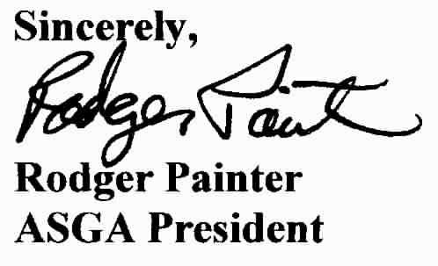

c.c. House Special Committee on Fisheries
Cora Campbell, ADFG
Ron Josephson, ADFG
Cynthia Pring-Ham, ADFG

