Texting And Driving Worse Than Drinking and Driving
Published: Thursday, 25 Jun 2009 | 11:54 AM ET
By: Phil LeBeau
CNBC Reporter
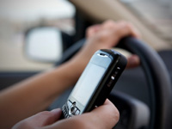
Admit it.
You've done it.
You've been driving down the side street (and yes, the highway as well) when your phone, blackberry, or whatever you use to call and text with goes off.
You immediately grab it, even though you are driving in traffic and really shouldn't.
It's a dangerous and terrible habit American drivers have developed.
The folks at Car and Driver Magazine have now documented just dangerous it can be.
Rigging a car with a red light to alert drivers when to brake, the magazine tested how long it takes to hit the brake when sober, when legally drunk at .08, when reading and e-mail, and when sending a text. The results are scary. Driving 70 miles per hour on a deserted air strip Car and Driver editor Eddie Alterman was slower and slower reacting and braking when e-mailing and texting.
The results:
- Unimpaired: .54 seconds to brake
- Legally drunk: add 4 feet
- Reading e-mail: add 36 feet
- Sending a text: add 70 feet
When I took the test for reading e-mail or texting, I was just as slow to react. On average, it took me four times longer to hit the brake. Mike Austin at Car and Driver told me in blunt terms that I was "way worse" than the average driver.
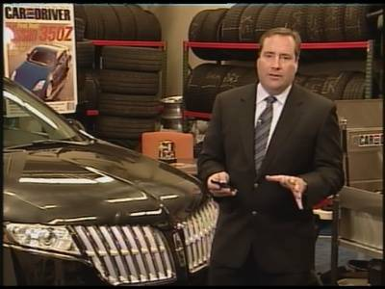

None of this should surprise you.
Sure, the headline about texting and driving being more dangerous than drinking and driving got your attention.
Maybe that's because the American public correctly views drinking and driving as wrong. But when it comes to texting and driving, we are not as outraged.
Probably because many of us have done it and still do it (even though it's banned in 14 states).
Sadly, it will likely take more accidents and more deaths to change that attitude. There are countless stories of teens dying in accidents because the driver was texting while driving.
Unfortunately, I fear there will be more. Too many people have become too accustomed to checking e-mail or sending a text while behind the wheel, even though it's as dangerous as drinking and driving.
AUTOS & CELL PHONES on CNBC.com

