Alaska State Legislature
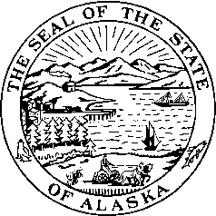
Interim: Session:
716 West 4th Ave. State Capitol Building
Anchorage, Alaska 99501 Juneau, Alaska 99801-1182
(907) 269-0199 (907) 465-4945

Senator Kevin Meyer
Senate District O

SPONSOR STATEMENT FOR CSSB 151
“An Act relating to mitigation at sentencing in a criminal case for a defendant found by the court to have been affected by a fetal alcohol spectrum disorder.”

SB 151 would include Fetal Alcohol Spectrum Disorders (FASD) as a mitigating factor in sentencing. This would allow some flexibility in sentencing if the defendant is found by the court to be affected by FASD and this condition substantially impaired the defendant’s judgment, behavior, and capacity to recognize reality or ability to cope with the ordinary demands of life.

Individuals diagnosed with a fetal alcohol spectrum disorder (FASD) are disproportionately represented within Alaska’s criminal justice system. SB 151 does not require a judge to use the mitigating factor and it DOES NOT automatically adjust a presumptive sentence. The defense would have to provide clear and convincing evidence that the defendant’s disability significantly affected the defendant’s conduct and substantially impaired judgment, behavior, and capacity to recognize reality in order to apply the mitigating factor.

Evidence shows that directing people with mental illness and other brain disorders to supported services, both inside and outside of Corrections, significantly reduces the high financial and social costs associated with re-incarceration and recidivism. Felons and repeat offenders with FASD are more likely to stop committing crimes when they are given the same supports that benefit people with mental illness and other disabilities, which can include Therapeutic Court, housing and employment assistance, case management, counseling and rehabilitation.

