Alaska State Legislature

Interim:
50 Front Street, Suite 203
Ketchikan, AK 99901
Phone: (907) 247-4672
Fax: (907) 225-7157
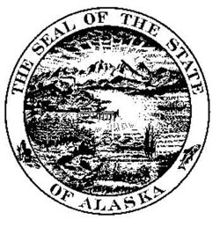

Session:
State Capitol, Room 114
Juneau, AK 99801-1182
Phone: (907) 465-3424
Fax: (907) 465-3793

Representative Kyle Johansen
House District 1

Sectional for HB 182 - "An Act relating to distribution of annual reports by state agencies."

Section 1. Grants municipalities the authority to pass an ordinance that will allow electronic notice to taxpayers on the municipality’s public Internet website instead of newspaper publication of the amount of state aid a municipality receives and the millage equivalent.

Section 2. Allows a municipality to meet notice requirements by posting its foreclosure list for delinquent taxes on the municipality’s public Internet website.

Section 3. Allows a municipality to electronically post notice that the redemption period following foreclosure will expire in 30 days on its public Internet website.

Section 4. Creates a new article requiring electronic production and distribution of agency reports if the agency has the technological capability to do so. Requires that reports must be posted for one year or until superseded. Creates exceptions where printing is required by other law, agreement or requested. Allows electronic distribution to fulfill any agency obligation to publish, prepare, present, or submit a report. Clarifies that print copies of reports may be requested from a library distribution and data access center. Defines “report” and “state agency”.

